AFGHANISTAN FEMALE YOUTH EMPLOYMENT INITIATIVE (FYEI)

NUTRITION EDUCATION

Nutrition during particular times in the life cycle: pregnancy, lactation, infancy, childhood and adolescents
ISLAMIC REPUBLIC OF AFGHANISTAN
MINISTRY OF EDUCATION

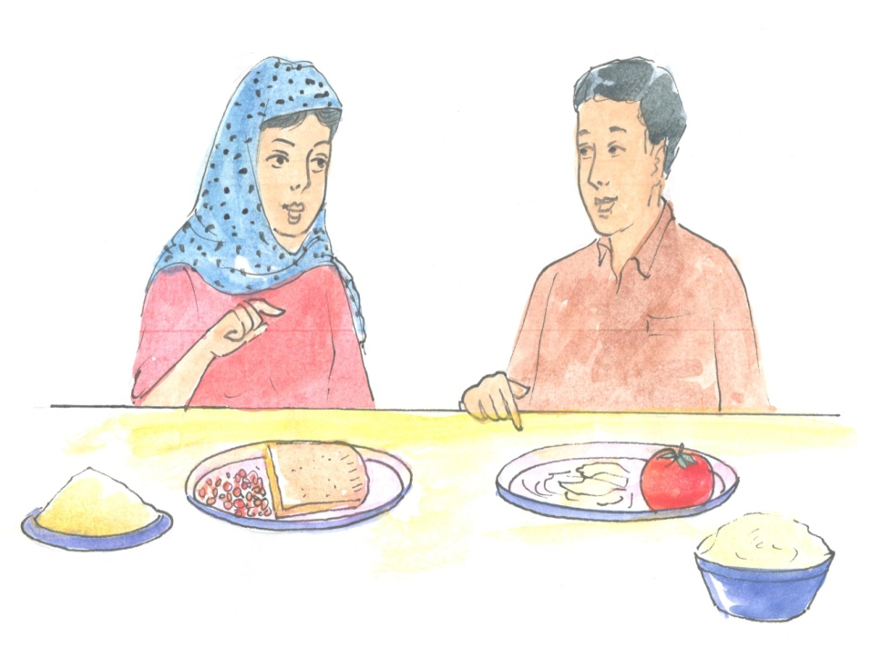

1: Preface:
Investments in nutrition and in education are essential to break the cycle of poverty and malnutrition in Afghanistan. The Ministry of Education of the Islamic Republic of Afghanistan believes that female youth can make an important contribution to the national efforts to overcome hunger and malnutrition, and that nutrition education modules can help to improve the nutrition and education of female youth and their families in both rural and urban areas. In this regard, it is important to stress that incorporating nutrition education in the Female Youth Employment Initiative (FYEI) Curriculum, and developing nutrition education modules for the Curriculum, are both important platforms for improving the nutrition status of our Country’s female youth.
We extend our sincere thanks to the World Bank in Afghanistan for their technical and financial support to the Adolescent Girls Initiative (AGI) and the Education Quality Improvement Program (EQUIP) in the preparation of these nutrition education modules. In particular, we would like to thank Mr. Luc Laviolette, Ms. Miki Terasawa, Ms.Najla Sabri and Dr. Tawab Hashemi for their commitment to this initiative.
The Ministry of Education and the World Bank appreciate the technical support provided by Dr. Wassima Qarizada, a consultant to the World Bank for developing the curriculum, and by Professor Ian Darnton-Hill AO, also a consultant to the World Bank, for his technical support and editing of the English version of the Female Youth Employment Initiative nutrition education modules. We especially thank the support of various stakeholders in the development, editing and designing of the final version of these Female Youth Employment Initiative nutrition education modules. I am confident that dissemination and teaching of FYEI nutrition education modules in Afghanistan will improve the nutrition awareness of Afghan female youth and their families to follow a healthy diet and help to reduce under nutrition and hunger in the country.
Thanks again for joining us, once again, in our goal of making the Afghan nation healthy and ready to continue to rebuild its future.

2: Acknowledgement
The Adolescent Girls Initiative (AGI) Afghanistan Female Youth Employment Initiative (FYEI) Education Quality Improvement Program (EQUIP)of the Ministry of Education and the World Bank team would like to thank the many people who gave their advice and guidance during the preparation of the nutrition education modules. In particular, we wish to express sincere gratitude to Dr. Wassima Qarizada who accepted our request for developing the FYEI Nutrition Modules as it would not have been possible to do so without the kind support and help of all who contributed. Building on the previous work and contributions of many national and international partners, she provided technical and coordinating support in the development of the Nutrition Modules for the Female Youth Employment Initiative project in Afghanistan. With advice from Professor Ian Darnton-Hill AO, a consultant to the World Bank. The development of these FYEI Nutrition Modules would not have been possible without the active involvement and support from the Ministry of Education– Dr. Seddiq Weera, and Dr. Obaidullah Hairan of the Female Youth Employment Initiative project., and from Dr. Bashir Hamid, Director of the Public Nutrition Department of the Ministry of Public Health and his colleagues - they spared us their valuable time to chair and greatly contribute to the multi-stakeholder meetings and workshops.
Special thanks are due to all the World Bank and MoE /FYEI members especially Ms. Najla Sabri, M. Haroon Chakhansuri, and Ms. Wahida Obaidy, along with Luc Laviolette, Tawab Hashemi and Miki Terasawa, who all contributed a great deal to the development of the FYEI Nutrition Modules through the conducting of the participatory workshop and meetings, as well as by financial support. Words are inadequate when offering our thanks to the Finalization Workshop participants and participants of the Second Participatory Meeting in MoPH, who shared their knowledge, their ideas, and provided essential feedback on the draft nutrition modules- all of which culminated in the finalization of FYEI. Thank you all for helping us.
The World Bank/MoE FYEI wishes to thank the following organizations, agencies for their support during the development and launch of the Female Youth Employment Initiative for the female youth of Afghanistan.

LIST OF INSTITUTIONS SUPPORTING DEVELOPMENT OF FYEI NUTRITION EDUCATION MODULES

No | Name | Organization
1 | Dr Bashir Ahmad Hamid | MoPH
2 | Dr. Ahmadwali Aminee | MoPH
3 | Dr. Homayoun Ludin | MoPH
4 | Ahmad Nawid Qarizada | MoPH
5 | Dr. Ahmad Nawid Qarizada | MoPH
6 | Seddiq Weera | MoE/EQUIP
7 | Dr. Obaidullah Hairan | MoE/FYEI
8 | Wahidullah | MoE/FYEI
9 | Mrs. Hamasa Murad | MoE/FYEI
10 | Abdul Mosawer Barakat | EQUIP
11 | Ibrahim Hamim | EQUIP
12 | Farid Sohil | EQUIP
13 | Raz Mohammad Fedai | EQUIP
14 | Saifura Brakzai | EQUIP
15 | Faizullah Faiez | MoE/Curriculum Development
16 | Alliaulla Jalil | MoE/Curriculum Development
17 | Mariam Munasa | MoE/Curriculum development
18 | Parwin Qarizada | MoE/Curriculum development
19 | Rabia Mansoor | MoE/Curriculum development
20 | Shakila Dost | MoE/Curriculum development
21 | Frozan Khamosh | MoE/Curriculum development
22 | Dr. Ahmad gul Iqbal | CHA
23 | Dr. Maiwand Habib | CHA
24 | Najia Anwari | CHA
25 | Dr. Zarjan Zahid | CHA
26 | Anjuma Naemi | MoWA
27 | Prof. Ian Darnton-Hill AO | The World Bank Consultant
28 | Najla Sabri | The World Bank
29 | M.Haroon Chakhansuri | The World Bank
30 | Miki Terasawa | The World Bank
31 | Luc Laviolette | The World Bank
32 | Dr. Wassima Qarizada | The World Bank consultant

3: INTRODUCTION
Undernutrition remains a significant problem in Afghanistan. Stunting in children under 5 years of age is over 55% - the highest in the Region. Undernutrition, even when moderate, both weakens the immune system and increases the likelihood of morbidity and mortality from infectious diseases. Women and young children are the most affected, resulting in high levels of low birth weight and in stunting of young children - both with life-long impacts. Over 20% of women are undernourished and micronutrient deficiencies are at levels of serious public health concern, especially iron deficiency anaemia (almost half of all non-pregnant women and even higher levels in young children and pregnant women). Young adolescent women are the key to breaking this cycle of undernutrition, where small and stunted women give birth to low birth weight babies who are in turn stunted and so it goes on across generations.

To have an impact on stunting, it will be necessary to break this cycle and improve other factors impacting on nutrition and health, such as women’s illiteracy rates. There will need to be a multisectoral approach, especially one that addresses education, women’s standing in society and food insecurity.
Two of the proposed such activities by the Ministry of Education (MOE) are the incorporation of nutrition topics into curriculum development, and behavioral change communications whereby students and teachers will be utilized as community change agents working collaboratively with community health workers. Both vocational and life skills training are proposed to be offered to students to stimulate careers as community health workers or as agricultural extension agents.
The nutrition education modules have been developed to prioritize these issues. The nutrition education topics included in the six modules include a range of different subjects appropriate to the level of female youth in Afghanistan. Each lesson contains lesson objectives, ‘ask yourself questions’, a content section for reading, students’ activity, a take-away message, an evaluation and home work. It will be emphasized to the students to take these health and nutrition messages both home and into their communities.
For doing the homework, the parents also have their roles; indeed it is a way of involving the parents in nutrition education. Furthermore, the MOE Female Youth Employment Initiative team, with the support of the World Bank, will aim to conduct seminars, parent-teacher meetings, and food demonstrations, regarding food and hygienic issues.
The World Bank/MOE FYEI team hopes that, with the development of the first nutrition education curriculum and modules for Afghan female youth, this will partly contribute to reducing high rates of malnutrition and child mortality and morbidity in the country.

Contents
Chapter1. The life cycle
Lesson1: The human life cycle
Lesson2: The life cycle stages
Chapter2. Nutrition during particular times in the life cycle: pregnancy, lactation, infancy, childhood and adolescents
Lesson1: Why women should eat well
Lesson2: Feeding of women and girls of reproductive age
Lesson3: Feeding pregnant women
Lesson4: Feeding lactating mothers
Lesson5: Infants food needs
Lesson6: Exclusive breast feeding
Lesson7: Complementary feeding
Lesson8: Food needs of preschool children
Lesson9: Food needs of school age children
Lesson10: Food needs of adolescents
Chapter2. Special food needs (Recipes for sick children)
Lesson1: Healthy foods for improving diarrhoea
Lesson2: White rice
Lesson3: Shurba- Bring
Lesson4: Food for a cold
Chapter3. Improved food recipes
Lesson1: Shir- Brinj
Lesson2: Potatoes with bean
Lesson3: Halwa of wheat and milk
Lesson4: Firni
Lesson5: Pumpkin with egg mix (korma kadu)
Lesson6: Cabbage stew (korma karam)
Lesson7: Eggplant stew (korma Badanjan)
Lesson8: Okra stew (korma Bamia)

CHAPTER 1
THE LIFE CY

Chapter1
The life cycle
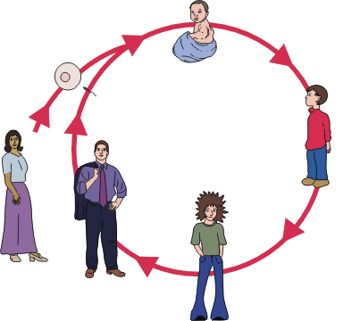

Lesson1
The human life cycle

Objectives
You are going to learn and talk about:
Plotting human growth during pregnancy
Analyzing how babies grow

ASK YOURSELF

- Do I know how the life cycle beginning?
- Do I know how babies grow?
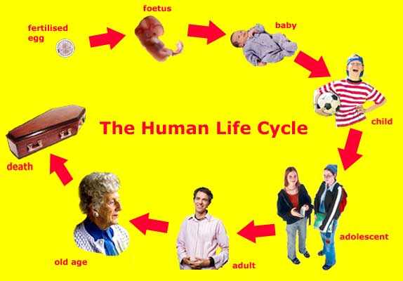

READING
The human life cycle begins at fertilization, when an egg cell inside a woman and a sperm cell from a man fuse to form a one-celled zygote. Over the next few days, the single, large cell divides many times to form a hollow ball of smaller cells.
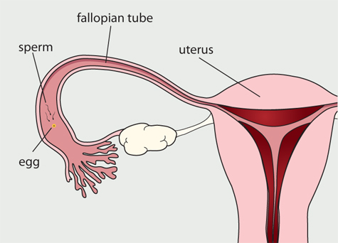
On the sixth day after fertilization, this hollow ball burrows into the wall of the mother’s uterus, or womb.
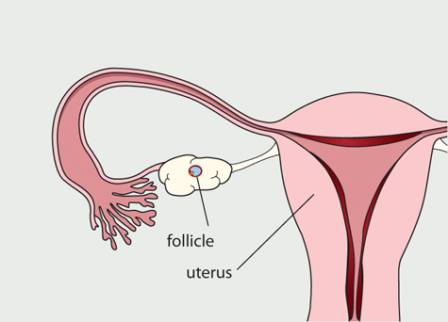
The cells then form three layers that fold and bend into the more complex shape of an early embryo. Gradually, the cells begin to become different from one another, forming, for example, the nervous system and the circulatory system.
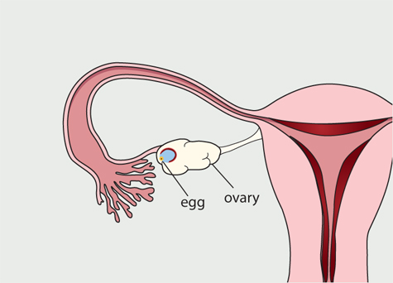
On the twenty-second day after fertilization, a simple tube like heart begins to beat. The embryo has no other working organs: the first brain activity will not begin for five more months. But in just one more month, all the major organs will have formed in miniature, including tiny eyes and ears, liver, and kidneys. These organs do not work, but they are there. Once all the organs have formed, the individual is called a fetus. During the fetal period, all the organs begin to mature. Cells from the embryo and its mother also combine to form a placenta, an organ in the uterus that connects the embryo to the mother’s blood supply. The fetus receives all its nutrition from the mother through the placenta-this is why the nutrition and health of the mother is so important.
A medical doctor would say the heart begins beating at five weeks. The total time from fertilization to birth is about thirty-eight weeks. At the end of the embryonic period (eight weeks), the embryo is about 30 millimeters (just over 1 inch) long. Between three months and nine months the fetus grows until it is about twenty times as long as it was just six months before.
Within a few minutes after the baby is born, it may begin to nurse. It is important to feed the baby from the mother’s breast within the first hour of birth. Babies are protected when they start feeding within the first hour after birth, especially as the early milk is higher in protective factors (and the bodily contact with the mother helps adjust to the new life outside the womb).
Human milk is far better for babies than bottled formula or other alternatives. For example, human milk contains antibodies and immune cells that protect the infant from infections. Babies who eat solid foods too early (before 6 months) seem to be more subject to allergies later in life and are certainly at risk of dying of infectious disease from unclean fluids and solids.
STUDENTS ACTIVITY (1)
Discuss the following question:
When the human life cycle begins at fertilization?
REMEMBER MESSAGE
Babies are fed best with breastmilk from within 1 hour of birth until 6 months of age.

EVALUATION
- How does the human life cycle begin?
- When is the potential individual called a fetus?
- Why is breastfeeding within 1 hour so important?
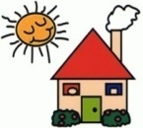HOMEWORK (1)
Read the READING part to yourself; explain the important parts to your sisters and peers.

Lesson2

The life cycle stages

Objectives
You are going to learn and talk about:
Analyzing requirements for growth.
Investigating growth in humans.

ASK YOURSELF
- Do I know the human life cycle stages?
- How many stages will be in human life cycles?

STUDENTS ACTIVITY (2)
Discuss about the following question:
How many stages are in human life cycle?

READING

Birth is the first stage. Before birth, a person begins as a single cell, with a contribution from both the mother and the father, the tiniest building block of life. As the human cells duplicate and specialize into specific body parts, they prepare for the birth of an infant, weighing 2.5-3kg, which takes about 40 weeks from the time that the first cell starts growing.
Fetus
Babies grow within the womb of their mothers. The medical profession divides all pregnancies into three trimesters – a period of three months. This division is useful because various events, signs, and developments tend to appear in different trimesters. From a length of three inches and a weight of one ounce, the fetus grows to some 14 inches and a weight of two and quarter pounds at the end of the second trimester. Movements of the fetus become noticeable at about 20 weeks or midway through the second trimester. The mother’s weight gain is the most rapid during these three months, averaging close to a pound a week.
Within the first week, three layers of cells form which will later be the start of all organs. The outer layer produces the nervous system, skin, nails, hair, and tooth enamel. The middle layer produces the bones, muscles, kidneys, and circulatory system. The inner layer produces the respiratory and digestive system and the glands.
The genetic material directs the number of cells at a given time in the growing baby. Two cells (the original egg and sperm) divide into the 6 trillion cells of a newborn baby.
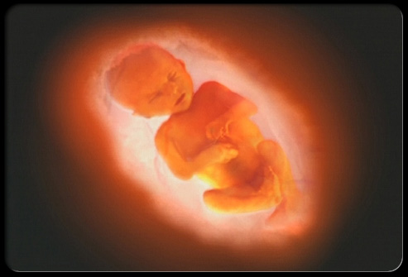

The rate of growth is greatest between the 18th and 22nd week (4th-5th months). The baby turns around because its head must come out first. The baby turns until it gets into that position.
Infancy is the second stage. From birth through the first year of life, a person is called an infant. The infant is totally dependent upon his or her parents for food, changing, bathing and movement from place to place. This is a stage in which a person begins to learn lots of things about survival in the world. Infants’ bodies grow and develop rapidly, though not as fast as the brain. After age thirty, human beings begin to age noticeably.
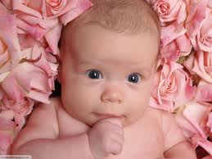
During infancy, between birth and one year, the brain undergoes an extensive and rapid period of growth. It is very important that the infant receive the right food during this period to ensure his/her body and brain develop fully. Indeed, the human brain continues to grow new neurons until the child is two years old.

Infants’ bodies also grow and develop rapidly, though not as fast as the brain. A one-year-old human typically weighs three times what he or she did at birth, has several teeth, and has begun to walk. During childhood (one to thirteen years), humans develop their first set of teeth, lose them, and begin to develop a second, or adult, set of teeth.
Childhood is the third stage, which lasts for about ten years. For the first two years after infancy, the child is called a toddler. Toddlers learn how to walk, talk and become more independent. For the balance of childhood, people grow, gaining more freedom and responsibility as they learn about themselves.
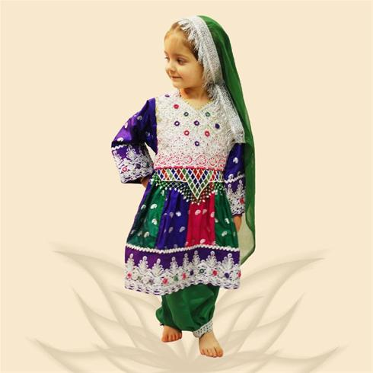
Between eleven and thirteen, children enter puberty. After puberty, adolescent humans can produce viable eggs and sperm, and many girls can carry a baby to term. Girls and boys develop secondary sexual characteristics, including body hair, deeper voices (especially in boys), breasts (in girls), and larger external genitalia (in both girls and boys). Boys begin to produce fertile sperm for the first time. Girls begin a monthly cycle of ovulation (releasing eggs) and menstruation (shedding the uterine lining) that will continue until they are in their fifties.
Adolescence is the fourth stage, roughly from age 12 to 18 years. In this stage, starting with puberty, boys change and become men, and girls become women. This can be a very confusing time for a young person, trying to cope with so many changes. This is the time that the human is preparing for adulthood, growing to his/her maximum size, and is physically able to reproduce.
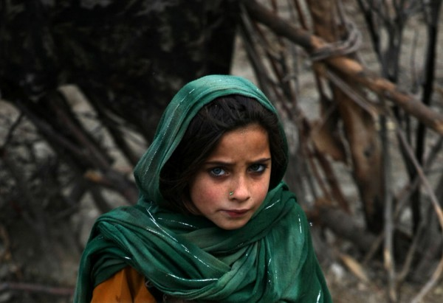
After puberty, men have 1.5 times as much bone and muscle mass as women, and women have twice as much body fat as men. Changes in the brain and in behavior also occur. By their early to mid-twenties, humans have reached their adult size. The bones stop growing and the brain is fully mature.
Adulthood is the fifth stage, from the end of adolescence, usually age 18 to 20, to old age. Adulthood is the time that people take on many different kinds of responsibilities. All of the things that our parents once provided, we must now provide for ourselves. The life cycle usually starts over again during this stage, when, through reproduction, adults give birth to their own children. Once a person’s children are grown up and are having children of their own, an adult can enter a more relaxing time of life, with freedom to pursue hobbies and travel. Though the body begins to break down during this stage, an adult can live to an average age of 76 and even longer in some places in the world.
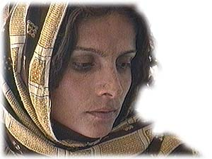
Humans in their twenties are in their peak reproductive years. Women who reproduce at this time have the least-complicated pregnancies. For males, the late teens and twenties are a time of peak death rates from accidents and other misfortunes, most likely due to the behavioral effects of high testosterone levels.
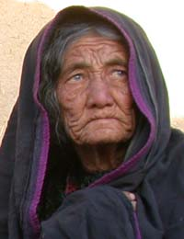
After age thirty, human begin to age noticeably. Hormone levels decline, skin becomes thinner and less flexible, gray hair and wrinkles appear, muscle mass decreases, bones lose calcium, blood vessels stiffen, and brain cells begin to die. Starting around age thirty-five, humans may lose one hundred thousand brain cells per day. The ears, the eyes, and other sensory organs also become less sensitive. Women gradually stop ovulating and menstruating in their fifties and men experience a slow decline in testosterone levels that is most often noticed in the fifties.

REMEMBER MESSAGE
Today, most people recognize the human life cycle as having five distinct stages shared by all humans.

EVALUATION
- How many stages are in human life cycle?
- When births take place?
- When infancy takes place?
- When childhood takes place?
- When adolescence takes place?
- When an individual is called adult?
HOMEWORK (2)
Explain the human life cycle stages for your peers, sisters and friends. And answer their questions.

Chapter2
Nutrition during particular times in the life cycle:
Pregnancy, lactation, infancy, childhood and adolescence

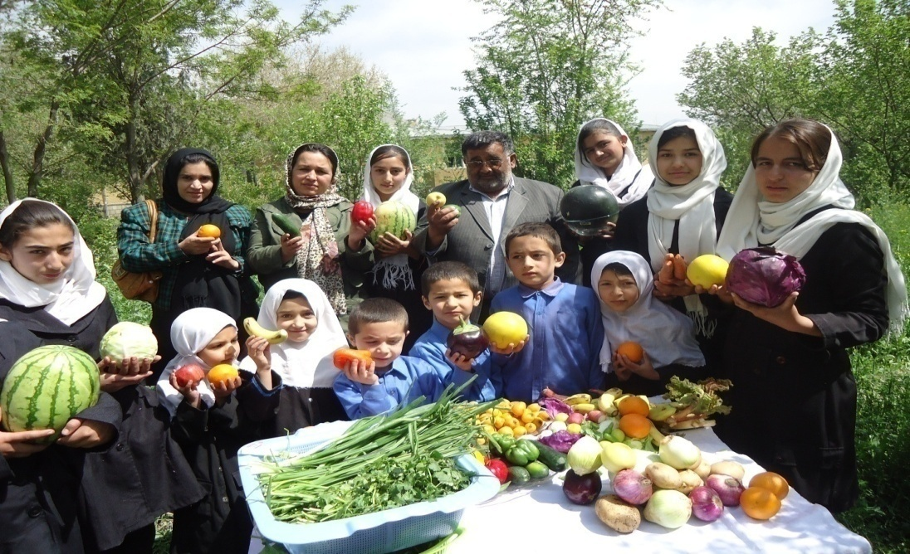

Lesson1

Why women should eat well

OBJECTIVES
You are going to learn and talk about:

- Women and girls need to eat well
- Reducing women risk of complications and difficult labor

ASK YOURSELF
- Is my diet enough to meet my needs?
- Is my mother eating enough?
- What will happen if a woman does not eat enough?

STUDENTS ACTIVITY (3)

Discuss the following question:

Why low birth weight babies are more likely to grow and develop more slowly than healthy babies?

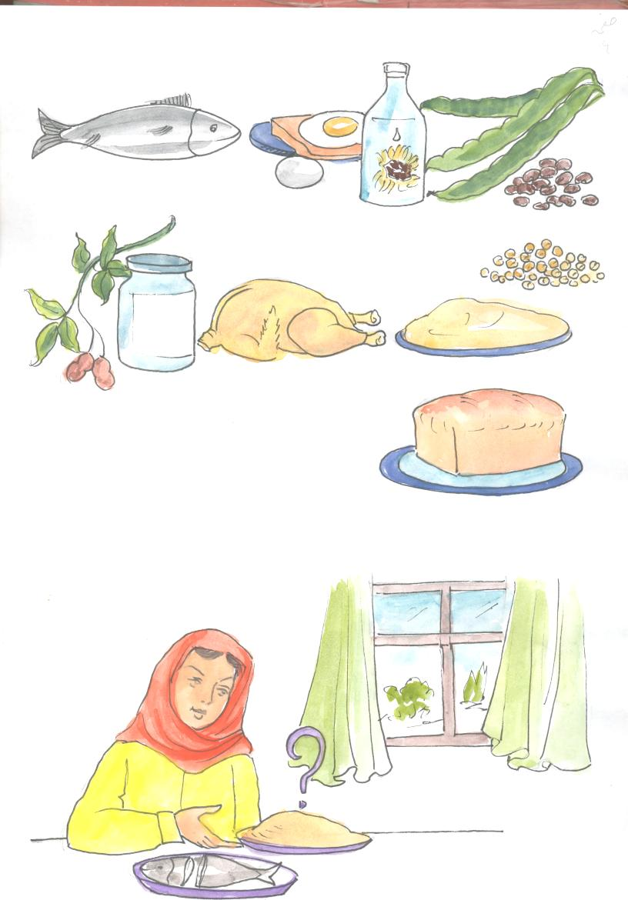What is missing in my meal?

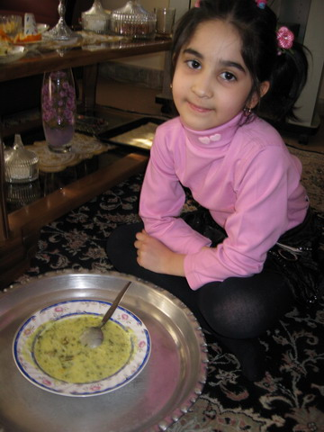

What is missed in my meal?

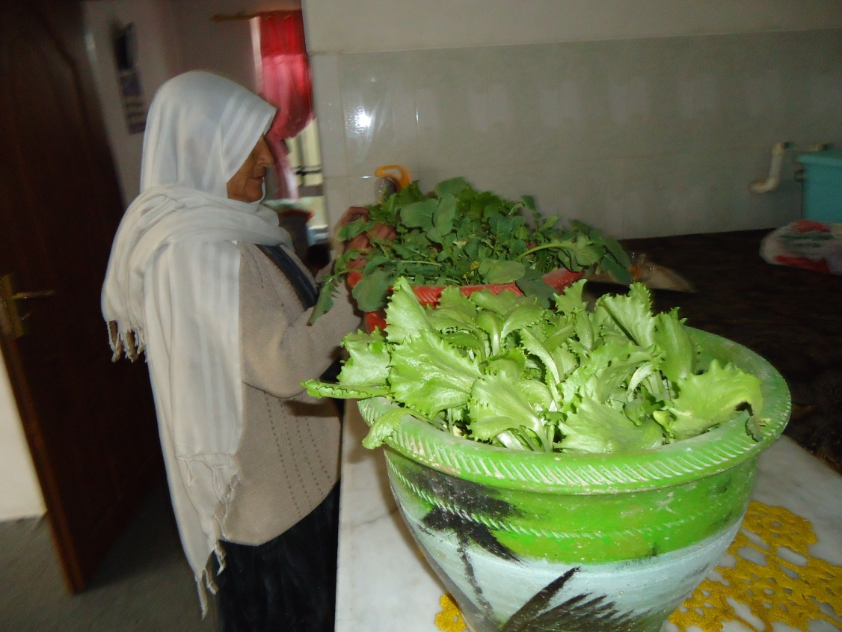
My micro garden helps me to have protective and nutritious food.

READING

Girls and women need to eat well throughout their lives but particularly when they are planning a baby, are pregnant or breast –feeding. If they eat healthy, balanced diets they are likely to:

- Stay active and well;
- Produce healthy babies and breastfeed successfully.

A woman is at risk of complications and a difficult labour if she is already under nourished when she becomes pregnant, or is undernourished during pregnancy and so does not gain enough weight during the pregnancy leading her newborn baby more likely to have a low birth weight (< 2500 g). Low birth weight babies are at greater risk than healthy newborns of:

- Growing and developing slower;
- Contracting an infection and of dying. The lower the birth weight the greater the risk of death;
- Having low stores of micronutrients that may result in disorders, such as anemia, and vitamin A and zinc deficiencies;
- Developing heart disease, high blood pressure, obesity and diabetes when adult.
Other causes of low birth weight are prematurity, malaria or other infections in the mother or the mother’s smoking or abusing drugs during pregnancy.
Pregnant women must attend antenatal visits at the health centre as early in the pregnancy as possible and at least three or four times. She should be weighed regularly and take her iron- folic acid (or multimicronutrient) supplements.
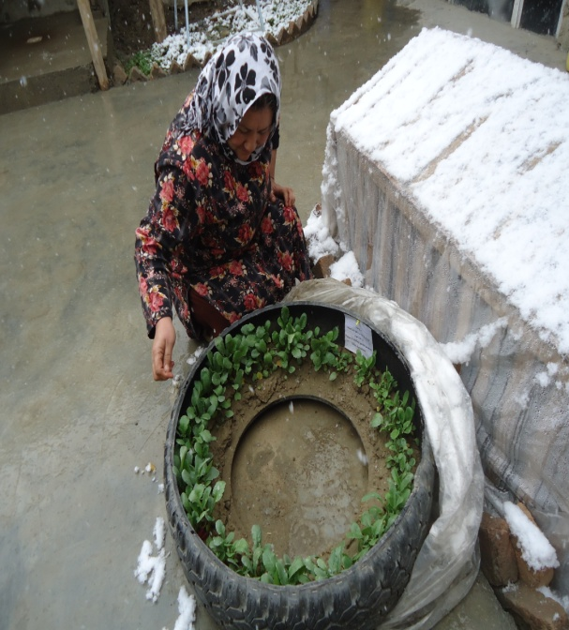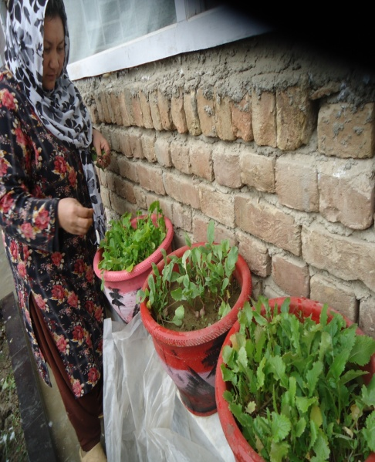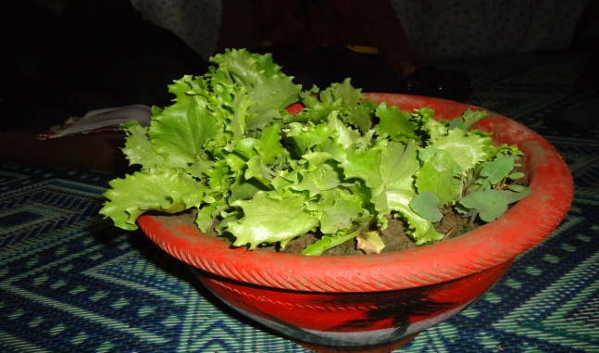
Having a micro garden helps my family to have green vegetables even in the harsh winter.

REMEMBER MESSAGE
Well- nourished mothers are likely to have healthy babies.

Is my diet healthy?
How can I improve my diet?
How can I prepare a healthy diet for my family?

EVALUATION

- Why do women need to eat enough of a varied diet?
- Why are women and young girls at risk?
- If a pregnant woman is undernourished, what is more likely to happen her newborn baby?
HOMEWORK (3)
Discuss with your family members and friends about the importance of women and young girls feeding well.

Lesson2

Feeding of women and girls of reproductive age

OBJECTIVES

You are going to learn and talk about:
- Nutritional needs of women and girls
- Pregnant women need extra food
ASK YOURSELF

- Is my mother well nourished?
- Are my sisters healthy?
- Do pregnant women need extra food?

STUDENTS ACTIVITY (4)
Discuss about the following question:
Why do women need extra food when they are pregnant or breastfeeding?

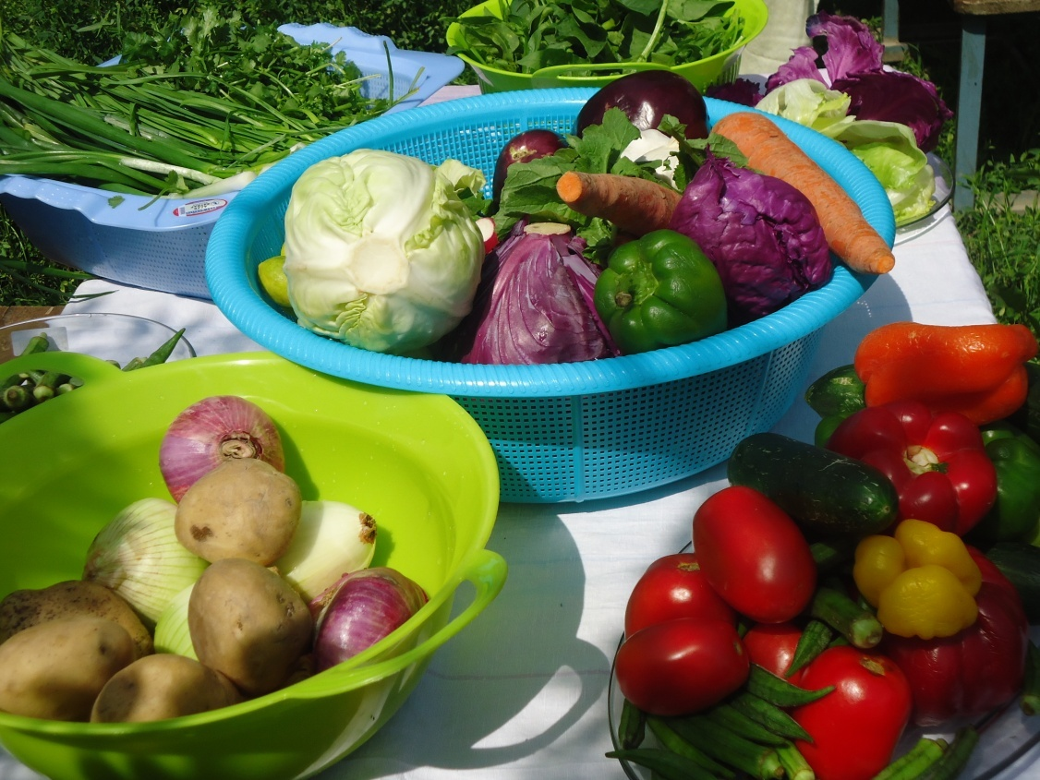

READING
Women of child-bearing age have certain nutritional needs above those of adult males. One reason is that the loss of blood during menstruation leads to a regular loss of iron and other nutrients and makes women more prone than men to anaemia. In addition, however, in our country women work much harder. In rural areas they are often heavily involved in agriculture, and in urban areas they may work long hours in governmental offices, factories and elsewhere; yet when they return home from the field or the factory or office they still have much work to do in the household, including food preparation and child care. Frequently the heavy burden of collecting water and fuel in the rural areas falls on women. All of this labour increases women’s needs for nutritional energy and other nutrients.
The nutritional status of women before, during and after pregnancy contributes a good deal to their own general well-being, but also to that of their children and other members of the family. The field of maternal nutrition focuses attention on females as mothers. It has often concentrated on their nutritional status mainly as it is related to the well-being of the infants that they produce and their ability to breastfeed, nurture and raises their children. The health and well-being of the mother herself has been relatively neglected. Similarly, the field of maternal and child health has put major emphasis on the child and on providing services and help to women mainly so that they can have successful pregnancies and lactations; this is also in the interests of the infant, without much concern for the mother. The dual role of women as mothers and productive workers is compromised by poor diets and ill health; not only their own well-being but that of the whole family is affected. A heavy work load may push a woman with marginal food intake over the brink and into a state of malnutrition.
A poor diet, frequent acute and some chronic infections, repeated pregnancies, prolonged lactation and a heavy burden of work may all contribute to serious physiological depletion and sometimes to overt malnutrition. The term “maternal depletion syndrome’’ has been suggested. In all provinces of our country young women in their late teens appear hearty, happy, healthy and attractive, but only ten or 15 years later, as young women in their late thirties, they are prematurely old, tired, down-trodden and unhealthy. Too often, the young female does not even live out her teens before her first pregnancy.

Women of reproductive age who are not pregnant or breastfeeding have slightly lower energy and protein needs than men but they need almost double the amount of iron (because of menstruation). Compared to men’s diets, the diets of women should provide:

- Slightly smaller amounts of staples, legumes and fats;
- At least the same amounts of vegetables and fruits;
- More iron-rich foods (meat, offal, poultry and fish).
Women’s needs for energy and most nutrients increase during pregnancy and breastfeeding. Iron needs during pregnancy are so high that it is usually advisable to give iron supplements, such as iron/folic tablets. Levels of anaemia are quite in Afghan women and so it is likely many young women will go in to their pregnancy already with insufficient micronutrient stores, and often underweight.
Make sure that women and their relatives know the following.
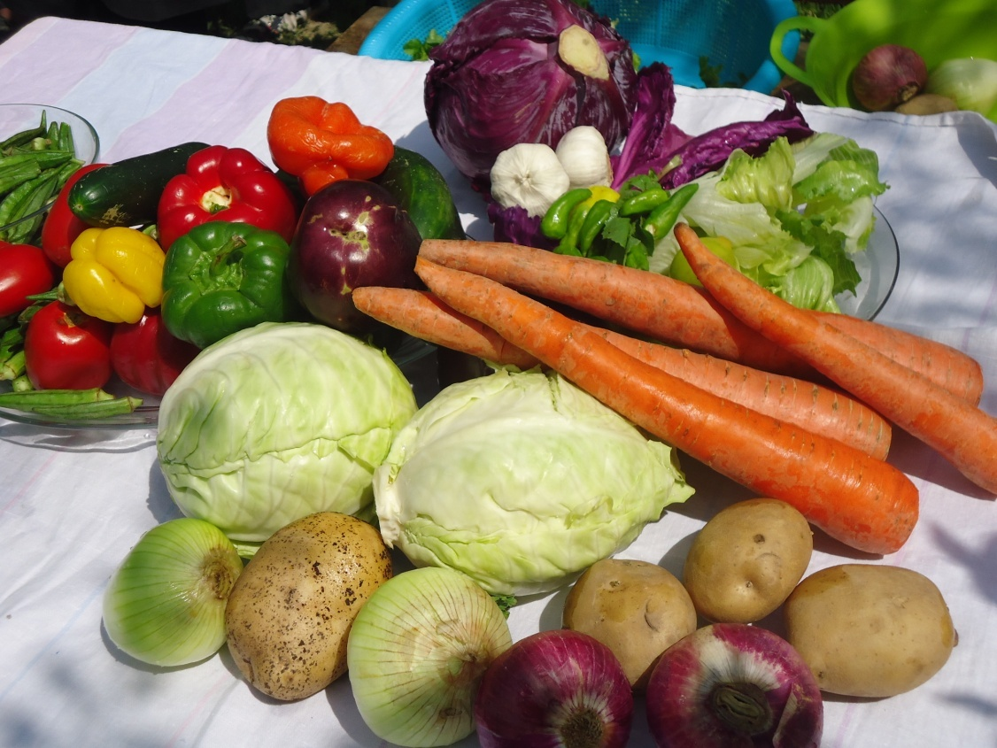

- All girls and women of reproductive age should:
- Eat a healthy, balanced diet that contains plenty of iron- rich foods;
- Have plenty of clean, safe drinks;
- Eat iodized salt. Women who lack iodine when they become pregnant are at greater risk of having a baby who is physically and mentally damaged.
- Pregnant and breastfeeding women and girls need extra food:
- When pregnant they need about 280extra kcal/day, more protein, zinc, vitamin A, vitamin C and folate, and much more iron (i.e. the equivalent of an extra nutritious snack each day). It is particularly important for women to eat well and be well nourished throughout their pregnancy, including the first trimester, so that the babies’ bodies and brains develop properly. Women should gain about 1kg a month in the second and third trimester of pregnancy.
- When breast feeding they need about 450 extra kcal/day and much more protein, zinc, vitamin A, vitamin c and folate(i.e. the equivalent of an extra small meal each day). Women should eat more at each meal or eat more frequently- perhaps having more snacks during the day.
- Women should eat well between pregnancies so they rebuild their bodies’ stores of nutrients.
A woman who is overweight or obese when she becomes pregnant should eat healthy meals but not ‘diet’. She should lose weight if she is still overweight after breastfeeding. There are increased risk to both mother and child of being very overweight when delivering.

At a certain time some women may need micronutrient supplements in addition to good meals. For example, most women need iron/folic acid tablets during pregnancy. A good diet should provide enough of the other micronutrients, including vitamin A. However, in situations where vitamin A or other micronutrients are likely to be deficient, women should receive low dose vitamin A supplements and/ or multimicronutrient supplements as soon after delivery as possible and not more than six weeks later. This provides a store for use during breastfeeding. Do not give high doses of vitamin A to any women who could be pregnant as they could harm her unborn baby.
REMEMBER MESSAGE
Nutrient needs increase during pregnancy and breastfeeding.

EVALUATION
- Why do women and girls of reproductive age need extra food and energy?
- Which foods are more useful for women and adolescent youth of reproductive age?
- When do women and adolescents of reproductive age need micronutrient supplements?
- Which supplements are more important in this age group?

HOMEWORK (4)
- Explain the reading part to your family members and friends in your own words.
- Find a woman or girl of reproductive age, research how her nutrition status, and diet, are. Note the positive and negative points. Next day present it to your classmates.

Lesson 3

Feeding pregnant women
OBJECTIVES
You are going to learn and talk about:
- Prevention of low birth weight babies
- Good health and nutrition when there is a likelihood of becoming pregnant.

ASK YOURSELF

- How can I help women and adolescent youth?
- How can I prevent low birth weight newborns?

STUDENTS ACTIVITY (5)
Discuss the following question?
How can low birth weight newborns be prevented?
Then explain the result of your discussion to all the class.

READING

During pregnancy a woman’s nutritional needs become greater shall at other times in her life. Her diet needs to provide all the elements needed for the growth of a fertilized ovum or egg into a viable fetus and baby. As the woman nourishes herself she also nourishes the growing fetus as well as the placenta to which the fetus in her uterus is attached by its umbilical cord. At the same time her breast tissue prepares for lactation.
During the first half of pregnancy extra food is needed for the mother’s uterus, breasts and blood – all of which increase in size or amount – as well as for the growth of the placenta. The increased need for food continues in the last half of the pregnancy, but during the last trimester the extra nutrients are required mainly for the rapidly growing fetus, which also needs to develop nutrient stores, particularly of vitamin A, iron and other micronutrients, and energy stores of fat. An adequate diet during pregnancy assists the mother to gain the extra weight that is physiologically desirable and helps ensure that the baby’s birth weight is normal.
Healthy women gain weight during pregnancy if they are not overworked. Just as a heavy person needs more energy to perform the same amount of physical work as a lighter person, a pregnant woman also needs more energy. However, in our country, pregnant women remain active, even during their last few months of pregnancy. The Basal metabolic rate (BMR) usually increases during pregnancy, which also raises energy requirements. Thus most women need more energy when they are pregnant, even if they are not overworked. For the overburdened woman of our country, who gets little rest and not much food, weight loss is a real and dangerous prospect.
A pregnant women should therefore :

- Eat a variety of foods, including plenty of the staples;
- Include fruits and vegetables in every meal;
- Include milk and milk products, beans, eggs or meat in the meal;
- Eat to the extent possible whole grain breads;
- Drink plenty of fluids;
- Eat 3 main meals and 2 snacks daily;
- Add butter or oil to increase energy density.

There is little doubt that abortions, miscarriages and stillbirths are more common in women who are poorly nourished than in those who are adequately nourished. Dietary deficiencies probably also increase the risk of producing a malformed fetus. Severe malnutrition reduces fertility and therefore the likelihood of conception. A severely malnourished woman ceases to menstruate. This is clearly a natural device to stop the loss of nutrients in the menstrual flow and to protect the woman from the rigors of pregnancy and childbirth.
The weight of the infant at birth is influenced by maternal nutrition. Low birth weights can be expected of infants born to malnourished mothers. Even a modest increase in energy intake during pregnancy tends to increase the birth weight of the infant.
In our country 50 to 75 percent of pregnant women have anemia. Anaemia often contributes to high maternal mortality rates. All pregnant women should attend a clinic at regular intervals for antenatal examination which should include checking of hemoglobin levels. Practical advice should be given regarding diet, taking into account what foods are locally available and what the mother can afford. It is accepted policy in many countries that pregnant women be advised to take medicinal supplements of iron, or sometimes iron-folate.
Infants of mothers who have poor vitamin A status are born with low vitamin A stores.
A diet with adequate amounts of vitamin A is clearly important during pregnancy, both for the mother and the baby. However, high medicinal doses of vitamin A, as are given to young children, are not recommended during pregnancy. In the case of many other nutrients, however, the child is truly parasitic and takes all the nutrients it requires irrespective of whether the mother has a deficiency or not.
In some cultures there is a fear that extra food given during pregnancy will make the baby too large and thus cause a more difficult or complicated delivery. This is not true for healthy women of normal size. Women of short stature or with a contracted pelvis may have difficulty in delivering babies and may require special care before and during delivery.
At the time of birth the mother loses blood, not infrequently 500 to 1000 ml, and she needs nutrients to regenerate that blood.

Other ways to help women and their unborn babies

You can help to improve the health of women and prevent their babies from having low birth weights by encouraging family planning. Advice parents to:

- Wait at least two to three years between pregnancies;
- Not have a baby when the women is too young (e.g. under 18 years) or too old;
- Wait at least six months between ending breastfeeding and becoming pregnant again. This gives time for women to ‘fill up’ and replenish their body stores of fat, iron and other nutrients and become strong again.
Exclusive breastfeeding is one contraceptive method (although not a totally secure one). A woman is unlikely to become pregnant if:

- She has not restarted her menstrual periods ;
- The baby is less than six months old and;
- The baby is breastfeed exclusively (e.g. has nothing else to eat or drink or suck).
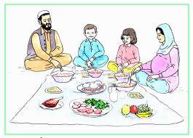
A pregnant women needs to eat diverse foods, including fruits.
REMEMBER MESSAGE
Spacing births can improve the health of women and babies.

EVALUATION

- Why are women and adolescent youth and young girls’ nutrition important?
- How can pregnancy be delayed?
- How can the health of women be improved?

HOMEWORK (5)

- Write an essay – How can the health of women, adolescent youth and young girls be improved?
- Next day read it to your classmates.

Lesson4

Feeding lactating mothers
OBJECTIVES

You are going to learn and talk about:
- Food requirement of lactating mother

ASK YOURSELF
- Do lactating women need extra food?
- Why their diet should be balanced and enough?

STUDENTS ACTIVITY (6)
Discuss the following question:
Why do breast fed others need good and enough diet?
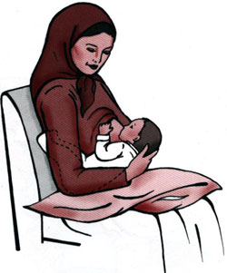

READING
The nutritional stores of a lactating woman may already be more or less depleted as a result of the pregnancy and the loss of blood during childbirth. Lactation raises nutrient needs, mainly because of the loss of nutrients first through colostrum and then through breastmilk.
Breastmilk volume varies widely, but for fully breastfed babies around four months of age, it is often 700 to 800 ml per day. It may rise later to as much as 1 000 ml or more. The nutrients present in this milk come from the diet of the mother or from her nutrient reserves. It is recommended that mothers exclusively breastfeed their infants for six months and then begin to introduce other food while continuing to breastfeed for as long as they wish, often into the second year or beyond.
During the period of exclusive or full breastfeeding the woman usually will not menstruate. The duration of amenorrhea varies from as little as four months to as long as 18 months or more. During that time the lactating woman will not be losing the iron normally lost with each menstrual period.
There is a widely held belief that the composition of breastmilk varies enormously. This is not so. Human breastmilk has a fairly constant composition, and is only selectively affected by the diet of the mother.
The fat content of breastmilk varies somewhat. The carbohydrate, protein, fat, calcium and iron contents do not change much even if the mother is short of these in her diet.
Lactating mothers should be encouraged to attend a clinic with their babies during the months after delivery. At the clinic both mother and baby should be examined. The mother should have her hemoglobin level checked and also her weight. Medicinal iron in the same quantities as recommended during pregnancy should be given. The mother should be given advice on consuming a mixed diet. This is also a good time to discuss the mother’s desire for further pregnancies and her view of the ideal spacing between pregnancies and to provide information and help regarding family planning. Relatively wide spacing between births is usually to the nutritional advantage of the mother the infant and even the next fetus. Narrow spacing between births prevents the mother from restoring her nutrient reserves before the next pregnancy, provides her with more work and a shorter time to care for her infant exclusively, and may influence her to breastfeed for a shorter period than is desirable.
At each postnatal visit both the mother and the baby should be examined, and advice on the diets of both mother and infant should be provided. A satisfactory gain in the infant’s weight is the best way to judge the adequacy of the diet of the infant. In the first few months when there is exclusive breastfeeding the infant’s adequate weight gain is a clear indication that the mother is producing sufficient breastmilk. Almost all mothers can successfully breastfeed their infants.

REMEMBER MESSAGE

The lactating mother should be given advice on consuming a mixed diet.

EVALUATION
- How much calories provided by one litter of milk?
- What are the contents of breastmilk?

HOMEWORK (6)

Find a lactating woman in your community, and discuss with him about nutrition needs during lactating period.

Lesson5

Infant’s food needs
OBJECTIVES

You are going to learn and talk about:
- Infant feeding.
- Colostrum is an important food for newborn.

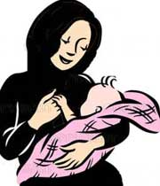
ASK YOURSELF
- Are mother milk is a useful food?
- Why infant 0-6 months of age should only eat milk?
- When they should feed with other foods?

STUDENTS ACTIVITY (7)
Discuss the following questions:
Do you have breast –feeding sister or brother?
What milk is he/she being feed?
Until what month will the feeding with breast milk continued?

The breast milk of mothers provides all the food and water necessary for an infant from birth to six months old.

READING

An infant is a young child less than 1 years of age (from birth until first birth day). An infant is most likely to be healthy, if the full-term birth weight is at least 2.5 kg.

A baby will triple his or her birth weight by the first birthday. By the time she reaches six months, her weight gain will start to slow down and weight gain will become more irregular due to growth spurts. The desired weight gain depends on the baby’s size, gestational age, and health. It might be as little as 5 grams a day for a tiny premature baby at 24 weeks, or 20 grams a day for a larger baby at 33 weeks and more for a full- term baby. In any case, a baby should gain about 15 g each day for every pound he or she weighs).
http://www.nlm.nih.gov/medlineeplus/ency/article/007302.htm
Provided that the mother has adequate breastmilk, breastfeeding alone with no added food or medicinal supplementation is all that is needed for the normal infant during the first six months of life. Exclusive breastfeeding means that not even water, juice or other fluids are provided; none of these are needed. This is true even in hot areas of Afghanistan. The infant should be examined regularly at the local health centre (clinic)or by a community midwife where weight gain is seen to indicate adequate nutrition. At the clinic a schedule for immunization will be set up, and this needs to be followed. Infants born with low weight (because of prematurity, for example) or twins may need special attention, and possibly iron or other supplements should be given. Up to six months of age many breastfed infants have considerable natural immunity to many infections.
As the children get older they gain weight and length. The increased energy requirements are based more on the weight of the child than on the age.

Infant and small children grow very fast and they are physically active when healthy and adequately fed. They therefore need a good combination of foods to support growth and development. If they are well fed, they will be happier and are likely to cry less. They will also not be sick as often and mothers will have more time for their own lives, as well as household tasks and other important duties. It is important the growth of the new baby is actively followed by weighing and by growth monitoring and promotion at the local health centre.

The first milk comes from the mother, called colostrum. Colostrum is an essential food for new- born babies. Colostrum is like a first vaccine for them. The mothers should give the thick, yellowish fluid (colostrum) from the breast because it is highly protective against infections and provides all the nutrients a baby needs.

Mother’s milk contains enough nutrients and enough fluids and water up to the age of 6 months; hence mothers should not give any other foods until the child is 6 months. Even in the summer months, infants under 6 months do not require water.

Successful breast –feeding with breast milk much reduces the danger of diarrhoea and other infectious illnesses in this period of life.

REMEMBER MESSAGE

Infants must feed only with breast milk till first six months of age!

Knowing whether the baby is getting enough milk
Many mothers are afraid of “not having enough milk”. Almost all women are able to produce enough breastmilk to feed their babies. Some of the signs that indicate whether the baby is getting enough milk are:
- One or two wet napkins (diapers) during the first few days, while the baby is receiving colostrum.
- Six to eight wet napkins per day (24 hours) on the third or fourth day of lactation.
- At least 2-5 bowel movements every 24 hours for the first several months.
- The baby feeding frequently, averaging 8-12 feedings per day.
The baby should be alert and active, appear healthy, and have good colour and firm skin.
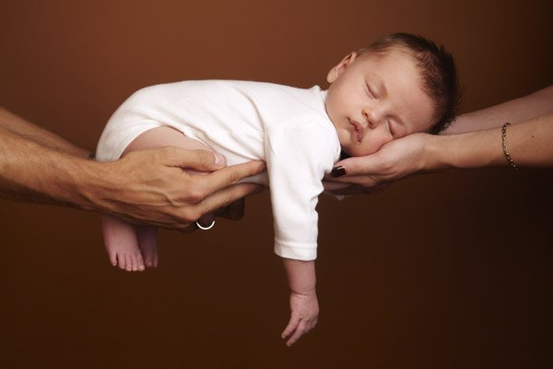

EVALUATION
- What food is the best one till six months of age?
- What is colostrum?
- Why should breast milk be continued till six months of age?
- When should an infant diet include extra (complementary) foods?

HOMEWORK (7)
- Speak about infant feeding with your family members.
- Write a short essay about infant feeding, next day present it to your classmates.

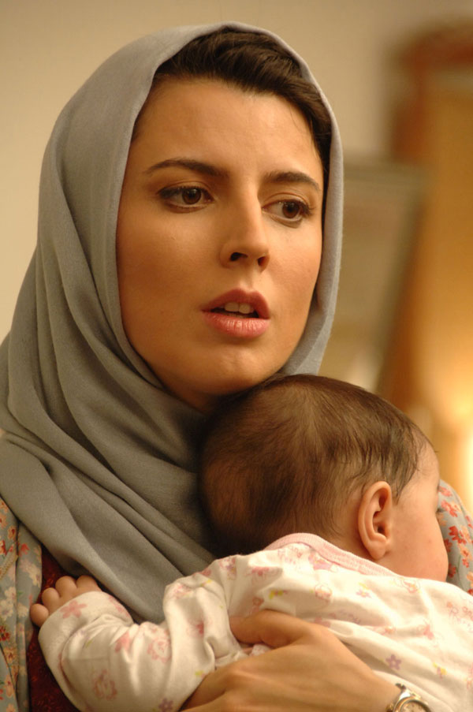

Lesson6

Exclusive breast feeding
OBJECTIVES
You are going to learn and talk about:
- The baby need just breast milk until six
months of age.
- Colostrum is the best first food for the baby.
ASK YOURSELF
- Why is colostrum an excellent food for newborns?
- Why we give colostrum to our babies?
STUDENTS ACTIVITY (8)
Divide in –to two groups. Discuss about the following questions:

What is exclusive breast –feeding?
Why is breast- milk the best food until six months of age?

One of the group members has to note the comments, and another one should present it to all the class.

Breast milk can supply all the nutrients needed for the six months of life and a useful proportion of the nutrients needed up to at least 2 years of age.

EXCLUSIVE BREASTFEEDING OF CHILDREN UNDER 6 MONTHS
Breastmilk is the only food that a baby should eat, until the age of 6 months because:

- Breast-milk contains all the essential nutrients and fluids necessary for the health and growth of the infant.
- Breast-milk is always clean. Other milks easily become contaminated.
- Breast-milk protects the infant from disease and death. Colostrums (fella), the first (yellow and thick) milk contains many immunogenic elements that protect the child, and is very rich in essential nutrients.
- Breast-milk is available all the time and requires no preparation
- Breast-milk is free
- Breast-milk contributes to a special relationship between mother and infant
- Mothers who practice exclusive breastfeeding do not become pregnant so soon.
Virtually all women are able to breast-feed but sometimes they may need some encouragement from the family and health workers to support her confidence.

READING
exclusive breast feeding means an infant receiving only breast milk from the mother, or expressed breast milk, and no other liquids or solids except drops or syrups consisting of vitamins, minerals supplements or medicines if needed e.g. when the baby was premature.
The mother should breast –feed exclusively until the baby is six months (180 days) old.

- Breast milk contains all the nutrients a full- term baby needs for the first six months of life. It provides enough water even in hot weather and is the safest source of water.
- Exclusive breast- feeding reduces the risk of diarrhea and other infections. Giving any other food or drink increases the risk of diarrhea.
- Exclusive breast feeding means the mother is much less to become pregnant.
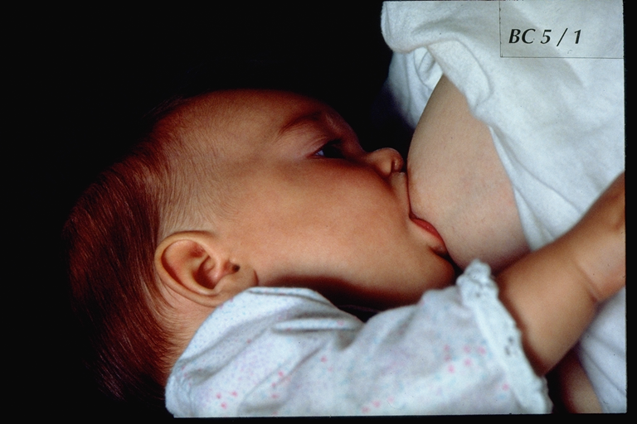
Ways to encourage exclusive breast milk include:

- Helping the baby to start suckling within one hour of birth- the mother and baby should be in skin contact immediately after birth.
- If necessary, explaining why colostrum is an essential food for newborn babies. Colostrums contain high levels of vitamin A and anti- infective factors that protect newborn from disease. Giving colostrum is like giving a first immunization. If a family has a wrong belief about colostrum (e.g. it is dirty), help them to understand it is safe, and is the perfect food for their new baby;
- Checking that the baby is suckling correctly.
- If necessary, explaining why families should not give baby any other food or drink.
- Advising the mother to feed ‘on demand’ (when the baby wants to feed) at least 8-10 times over 24 hours, and let the baby suckle for as long as he or she wants day and night;
- Dealing with breast –feeding problems (e.g. sore nipples, engorged breasts, thrush in baby’s mouth) promptly;
- Teaching the mother how to express and store her milk if she is away from her baby for more than three hours;
- Referring the mother to a local breast feeding support group if there is one.
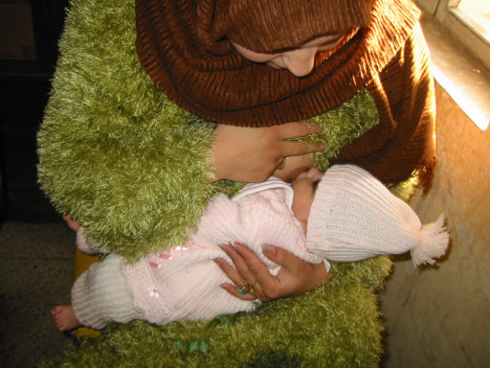
REMEMBER MESSAGE
Babies should breastfeed exclusively for six months.

EVALUATION
- What is exclusive breast –feeding?
- Why do we recommend exclusive breast feeding?
- Do breast fed babies need extra water?

HOMEWORK (8)
- Find out, how local babies aged 0-6 months are fed.
- Whether mothers exclusively breastfeed, and if so, for how long?
- Fill the blank spaces, with help of your family.
Exclusive breast- feeding means:
…………………………………………………………………………………….

Lesson7

Complementary feeding
OBJECTIVES
You are going to learn and talk about:

What is complementary feeding.
When to start complementary feeding.

ASK YOURSELF
- Do I know what is complementary feeding?
- What foods are given as a complementary food to infants in my community?
STUDENTS ACTIVITY (9)
Divide in to two groups:
Group1: what complementary foods are used in your community?
Group2: when women start complementary feeding in your community?

Then explain the result of discussion to all the class.

Remember!
- Wash hands with soap using clean
water before preparing food and feeding children
- Wash ingredients with clean water
before cooking
- Clean bowls, plates in hot water
and use dish washing liquid if available
- Provide boiled water to the child
Where possible, choose good quality
ingredients and products

READING
At six months of age complementary feeding should be introduced gradually while the infant continues to be breastfed intensively and to receive most of his or her energy and other nutrients from breastmilk and not from complementary foods. From six to 12 months, it is highly desirable that breastfeeding should continue and that the child should get as much milk as possible from the mother while other foods, first semi-solid and then solid, should be introduced to the diet of the infant for normal growth and health.
Breastmilk is relatively deficient in iron, and the infant’s store of iron is sufficient only until about six months of age. From six to 12 months, the normal infant may be expected to gain between 2 and 3 kg. The infant, while continuing to receive breastmilk, will now need foods to provide extra energy, protein, iron, vitamin C and other nutrients for growth.
The needed energy can usually be obtained from a gruel of whatever is the local staple food. The quantity and bulk can profitably be reduced if some edible oil or fat-containing food is also eaten. If the staple is a cereal such as maize, wheat, millet or rice, it will also provide a useful quantity of protein.
More important is the need to feed the young child frequently, with foods that are not too bulky and are both nutritious and of high energy density.
Legumes such as beans, peas, lentils, cowpeas, mung bean and groundnuts are good sources of protein and should be added to the diet of the child. They can be ground or crushed before or after cooking.
The above foods, as well as providing energy and protein, will also provide some iron. Additional iron can be obtained from green leafy vegetables, which also contain carotene and vitamin C. Carotene can also obtained from carrot, and vitamin C can also be obtained from fruits such as ripe mangoes and citrus fruits such as orange, lemon, mandarin. These fruits are excellent sources and are usually most acceptable to young children. Gradually, as more teeth erupt, the child can be put on a more solid diet. By the age of two or 2.5years, the child may have stopped breastfeeding and may be completely put on other foods.
The transition can be described as four stages:
- the first four to six months when all the infant’s nutrients come from breastmilk;
- the next few months when just as much (or more) breastmilk is provided but other appropriate, often soft, nutritious foods are introduced in increasing amounts, with efforts to prevent these from causing a decline in breastmilk consumption;
- the next stage, perhaps starting at about 12 to 15 months, when the baby is still breastfeeding but is getting considerably more of his or her nutrients from nutritious foods – most of them ordinary village or family foods than from breastmilk;
- the end of breastfeeding, the stage termed “sevrage” (a good French term literally meaning “severance from the breast”), which can occur as late as the mother wants, sometimes when the infant is over two years of age.
After stopping breastfeeding, appropriate family foods are provided. This need to be nutritious, suitable for the child, energy dense and given frequently, perhaps four to six times per day, not just in two or three meals per day as may be the family practice. The young child should be fed between family mealtimes if these are limited to two or three per day.
The mother responsible for feeding a toddler who is no longer breastfeeding must keep in mind that the child, whether boy or girl, has special needs.
Special needs of a young girl in the months following cessation of breastfeeding
- She needs a variety of foods, as great as or greater than that given to any other member of the family.
- She is growing rapidly and needs energy-dense foods and extra protein-rich foods.
- She has few teeth, and requires soft food.
- She has a relatively small appetite and intake capacity and needs more frequent meals than older persons.
- She requires clean food and clean utensils to avoid infection.
- She must as far as possible be protected from communicable diseases.
- She should have the love, affection and personal attention of her mother for her mental and, indirectly, her physical well-being.
- Attention from the father and other members of the family will also contribute to her development and well-being.
The proper feeding of a toddler requires time and patience. Special utensils or equipment are not necessary, but a sieve or strainer is useful. Adult foods can be chopped up and forced through a strainer into a cup or on to a plateful of gruel for the child. A strainer can readily be made if none is available. Otherwise, various foods can be crushed before cooking using a pestle and mortar, which are found in most households.
In some societies gruel or porridge made from the local staple is made sour or partially fermented. This is a good practice. Small amounts of germinated cereal seeds, often millet or sorghum, are crushed and added to maize or other porridge. The amylase present breaks down some of the starch, causing the porridge to become thinner (more liquid), so it is easier for the young child to consume, and making it more energy dense. The food is also safer, because the growth of disease-causing organisms is inhibited in sour or fermented gruel. Some societies sour children’s foods by addition of lime or lemon juice. This also is advantageous, and enhances the absorption of iron.
The period from six to 36 months of age is of paramount importance nutritionally. The mother should take the child regularly to a local health centre, if one is available. The happiness, general appearance and weight of the child are the best general indicators of adequate nutrition. Many children of this age in our country do not grow at the rate they should, and some develop protein-energy malnutrition.
The first three years of life are also those when the important micronutrient deficiencies of vitamin A and iron are most likely to occur in children. From three years of age the risks are reduced, but in many children growth continues to lag, incidence of intestinal worms and other parasitic diseases , diarrheal diseases and acute respiratory infections may increase and other nutrition and health risks arise.
From three years of age onwards the child has usually stopped breastfeeding and is consuming family foods. The child can now obtain adequate nutrients in three meals per day, but until the child reaches the age of five years, parents should make certain that the child is eating adequately and getting his or her fair share of the most desirable foods, which may well be those that are most tasty and in shortest supply. Special attention may need to be given when children have a poor appetite or when they are ill and their appetite is reduced. For the whole family, but especially for children, care must be taken that food, water and other fluids are safe and not contaminated. Good personal and household hygiene are of the greatest importance. Washing hands with soap and water before meals or food handling is a good family rule.
Parents should understand the needs of the child and see that the right foods are available in adequate quantities and prepared in palatable ways
It is clear that as children increase in weight and age they need more food to provide them with more energy and more of the other nutrients essential for growth and health. Thus a child aged six to 12 months and weighing 8.5 kg requires 950 kcal per day, whereas a child aged five to seven years weighing 19 kg requires 1 820 kcal [almost twice as much) and a boy aged 17 years weighing about 60 kg requires 2 770 kcal (almost three times as much).
Mothers need to understand that as children grow beyond infancy, they increase in weight and require more food to eat. As young boys and girls get older, heavier, taller and more active, they need to eat more food, especially a greater quantity of staple foods including cereals (e.g. rice, maize, and wheat) and legumes (e.g. beans, cowpeas).

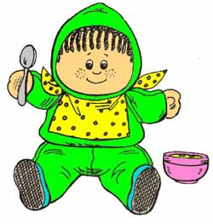What is complementary feeding?
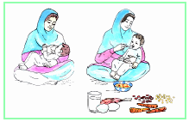

Complementary feeding means giving others foods in addition to breast- milk.

Improved local porridge: proportion of ingredients

Traditional wheat porridge recipes were improved by adding legume flour (bean, chickpea, lentil or mung bean), milk or eggs to the porridge.
The table below provides quantities of wheat and beans flours to use.
the proportion of wheat: beans is 2:1 that is:
the quantities of vegetables, oil and other bean substitutes (milk and eggs) are indicated in the table below:
2tablespoons of wheat for 1 tablespoon beans
OR
1 tablespoon of wheat for ½ tablespoon beans

Suggested improved recipes for complementary feeding
Improved recipes for complementary feeding are:
- Wheat with beans/check peas porridge
- Wheat with milk porridge
- Wheat with milk porridge
- Potatoes with egg porridge
- Potatoes with milk mash
- Potatoes with beans mash
- Potatoes with egg mash
- Firni
- Milky rice (shir-brinj)

Note: maize flour can be replace wheat flour in maize eating areas

Pounded vegetable options include: spinach, coriander, turnip and beetroot leaves, leek, wild leafy vegetables (i.e. Khorfa, shurak, charmaghzac, gandumak, etc.), dried leafy vegetables as well as mashed cooked carrots. This provides a much wider range of alternatives to promote.

Note: the availability of green leafy vegetables may be a real challenge during the late winter season, a time when supplies of both fresh and dried vegetables are low. Extension and home economics workers must therefore advise households to store and preserve (for example dry) more vegetables when supplies are good (in summer) for use during the winter months.
Depending on the season and the local food availability calendar, you select and promote recipes that are relevant to your region and season. In addition to the proposed complementary foods below, advise mothers to give snacks such as yoghurt, apricots, and ground pumpkin seed. Also encourage the use of whole grain flour and, when available, giving mashed liver to children. These are excellent for improving the children’s zinc and iron intake.
Wheat with milk porridge
Ingredients:
1 tablespoon wheat flour
¼ cup milk (1cup=250ml)
½ cup water
1teaspoon oil
1teaspoon pounded leafy vegetables(spinach or any other locally available leafy vegetables, including indigenous leafy vegetables) or mashed carrots
1teaspoon sugar
iodized salt to taste (preferably one light 2-finger pinch of salt)

Cooking method
- Mix wheat flour with milk
- Add water, mix and put it on fire to cook (10-15minutes)
- Add oil and sugar
- Add pounded vegetables and cook for 2-3 minutes
- Add iodized salt

Wheat with bean porridge
Ingredients:
1tablespoon wheat flour
½ tablespoon bean flour
1teaspoon oil
½ cups water
1teaspoon pounded leafy vegetables or mashed carrots
1teaspoon sugar
iodized salt to taste (preferably) one light 2-finger pinch of salt)
Cooking method
- Put the 1 cup of water and bean flour into the pot, mix well, bring to boil and simmer for 20 minutes.
- Using the remaining water (1/2 cup), make a paste of wheat flour and add it to the beans mixture in the pot
- Mix well and cook the mixture for 10 minutes
- Add oil and sugar
- Add pounded vegetables and cook for 2-3 minutes
- Add iodized salt
Wheat with egg porridge
Ingredients:
1 tablespoon wheat flour
1 egg
1 tablespoon oil
¾ cup water
1 teaspoon pounded leafy vegetables or mashed carrots
1 teaspoon sugar (optional)
iodized salt to taste (preferably one light 2-finger pinch of salt)
Cooking method
- Put the water into a pot and add the wheat flour, mix well, bring to boil and simmer for 5 minutes
- Add the egg, oil and sugar (optional) and cook for 2-3 minutes
- Add the pounded vegetables and cook for 2-3 minutes
- Add iodized salt

Potato and milk mash

Ingredients:
1medium size potato (about 100grams or ½ cup of chopped pieces of potatoes)
¼ cup milk
½ cup water
1teaspoon oil
1teaspoon pounded leafy vegetables or mashed carrots
Iodized salt to taste (preferably one light 2-finger pinch of salt)

- Peel potato, cut it into small pieces and cook in water until soft and the water is almost finished.
- Mash potato pieces
- Add milk and mix well
- Cook for 3-5 minutes and ass oil
- Add the pounded vegetables and cook for 2-3 minutes
- Add iodized salt

Potato and egg mash

Ingredient:
1 medium size potato (about 100grams or ½ cup of chopped pieces of potatoes)
1egg
½- ¾ cup water
1 teaspoon oil
1 teaspoon pounded leafy vegetables or mashed carrots
Iodized salt to taste (preferably one light 2-finger pinch of salt)
Cooking methods

- Peel potato, cut it into small pieces and cook in ½ cup of water until soft and water is almost finished.
- Mash potato pieces
- Add the egg and the remaining ¼ cup of water and mix well
- Cook for 3-5 minutes and add oil
- Add the pounded vegetables and cook for 2-3 minutes
- Add iodized salt
Be aware that:
- Between 6 and 8 months, give the child soft, mashed foods (without using too much water) 2 to 3 times a day, in addition to breast-feeding
- Between 9 and 12 months, give the child soft foods 3 to 4 times a day.
- Between 12 and 24 months, the child can share family foods, but should be fed 4 to 5 times a day, in addition to breastmilk and snacks.
- When the child is sick, feed him small quantities more often and give him more fluids. After the illness, the child should be fed more than usual.
- Use clean foods, and clean cooking utensils when preparing the food and feeding the child
- Always wash your hands before feeding the child
- Boil any water that you give the child
- Continue breastfeeding until 24 months

Feeding infants and young children
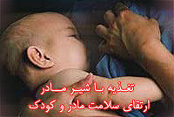
Small children grow very fast and they are physically active. They therefore need a good combination of the main family dish and other foods that are used to make relishes (beans, peas, lentil, fish, eggs, meats, leafy vegetables, cooking oils, etc).
Fats and oils, for example, palm oil or vegetable oil, such as sunflower, soybean, or corn oil, provide energy in a very concentrated form and are particularly useful for increasing the energy content of young children’s meals without increasing the bulk (volume or size) of the meals. This is important as children under two years of age have small stomach and can eat only small amounts of food at each meal. Because of this, they must be fed regularly throughout the course of the day.
If the child is adequately fed, he/she will be happier and is likely to cry less.
The child, who remains healthy and growing well, will not be sick as often and so the mother will have more time for household chores and other duties.
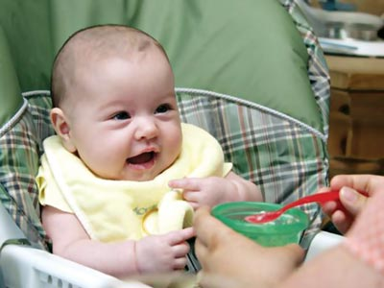
Feeding children after 6months
Introduce Good Complementary Foods
- From 6 months, breast –milk is no longer enough to support adequate child growth.
- Give enriched porridge to the child, starting with 2-3 tablespoons twice a day.
A good complementary food or porridge has:
A starchy staple food+ Legumes/nuts or eggs or flesh food+ vegetable+ a little oil
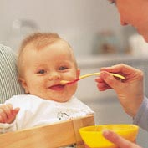
Feeding children at 7-8 months
Continue giving enriched porridge + breastfeeding
Children need three main meals of complementary foods. Try to gradually increase up to half a bowl (e.g. 125ml) per meal.
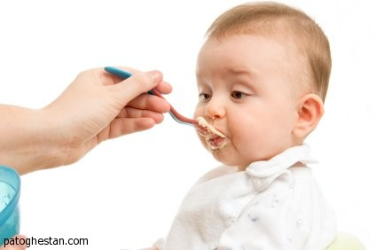
Feeding children at (9-11 months
Continue giving enriched porridge+ breastfeeding
Children need three main meals of up to nearly a full
bowl (of 125ml) per meal. Also give one snack
per day. Ripe banana, apple, mango, melon or watermelon, are all good snacks for children.
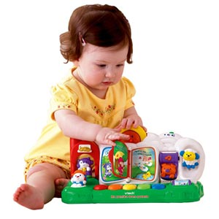
Feeding children (12-24 months)
Continue giving enriched porridge+ breastfeeding
Children need three main meals of a full bowl (of 125ml) per meal, plus two snacks per day. Ripe banana, apple, mango, melon or watermelon, are all good snacks for children.

REMEMBER MESSAGE
Complementary feeding means giving others foods in addition to breast- milk.

EVALUATION
- What is complementary feeding
- When should we start complementary?
- How can feed an infant between 7-8months of age?
- How can prepare an improved complementary recipe for an infant age 9-11months?
- How can feed a child between 12-24months?

HOMEWORK (9)
- Find out, how local babies aged 6-24 months are fed.
- Whether mothers familiar with some improved complementary foods? And if so, how they prepare the recipe? How many times a day she fed her child?
- Not all of them, next day share it with your classmates.

Lesson8
Food Needs of Preschool Children

OBJECTIVES
You are going to learn and talk about:
- Feeding of preschool children.
- Variety of food for preschool children.

ASK YOURSELF
- Can I remembering how my diet was in preschool age?
- How many times I ate different foods and when?
- Did I eat from a separate palate? Why? Why not?
STUDENTS ACTIVITY (10)
Discuss the following questions:
Why preschool children should be encouraged to healthy eating?
Why do these children need a variety of foods?

READING

Children from 2- 6 years of age need enough food to grow and develop and their stature to become tall.
Enough food provides them energy to play, run, walk, and fight infections. Starting good feeding habits in the first stages of life help children to have good nutrition habits in to adulthood. Because this period is very essential in their life, children learn most important habits during this time. When a young child learns to eat nutritious diet, he is more likely to do the same in adolescence and adulthood.
Preschool age children must therefore be encouraged to eat different foods, to be healthy. Foods that are good for this age group are: fish, meats, chicken, milk, and milk products, egg, rice, bread, butter, nuts orange and green fruits and vegetables- as much variety as possible!
By age 3 children can eat themselves. Families have to help them, by preparing the meals, and especially, by helping to feed them when they are sick. They should be given slightly different foods from the family diet e.g. of this age group should contain less salt, pepper and sugar. If at all possible, they need 3 main meal and 1-2 snacks. When families eat from one plate, it is better to give food in a separate plate for children. This will help to ensure the child is fed enough.
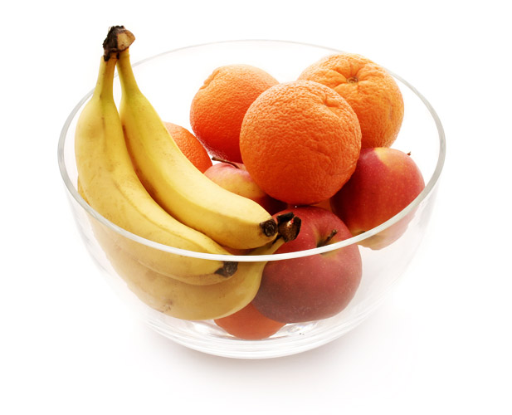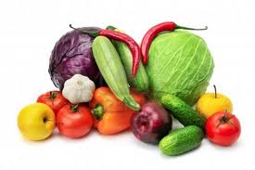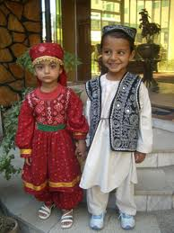
Preschool children’s diet should contain fruits and vegetables.
REMEMBER MESSAGE
Small children should eat from separate palate, to make sure they are getting enough to eat.

EVALUATION
- Why do preschool children need enough food?
- What foods are good for them? Why?
- What foods should limited at this age?
- Why should preschool children feed from separate plate?
HOMEWORK(10)
- Speak about preschool children feeding with your family members.
- If there is preschool child in your family, see how your family feed him. Note the wrong and right points. Next day present it to your classmates.

Lesson9
Food needs of school age children

OBJECTIVES
You are going to learn and talk about:
- Food needs of school –age children.
- Hungry children not paying attention to lessons.

ASK YOURSELF
- Do I need food before going school?
- Am I learning lessons- when I am hungry?

STUDENTS ACTIVITY (11)
Do a presentation about the following questions:
Why do we have to eat before going to school?
Can you learn your lessons, while you are hungry?

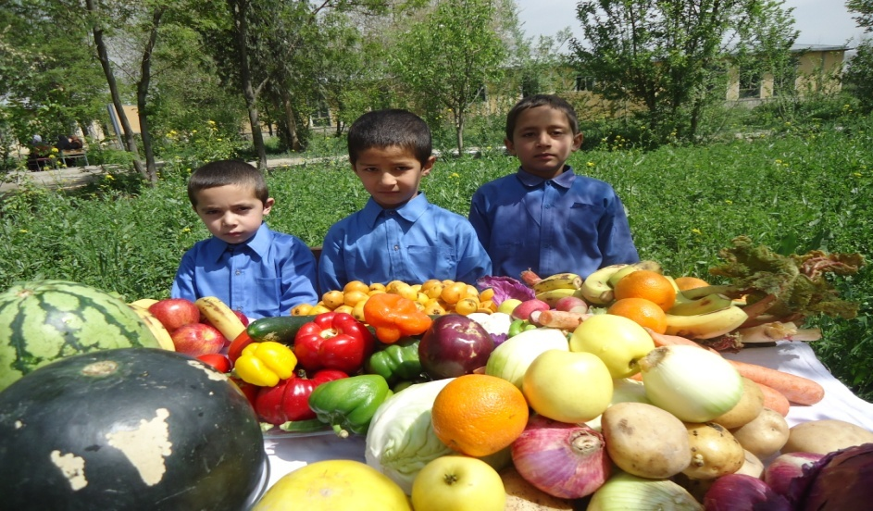

READING

School age children need a variety of nutritious and safe foods. Their diet should contain enough of the nutrients such as carbohydrates, protein, fat, vitamins and minerals. During the age of 7-12 growth and development increase more gradually (until puberty begins) . Furthermore, in this age group children are very active. So the amount of food should increase. As noted, the variety of food is very essential. Good feeding helps them, to do well at home and school.
Eating a healthy and good breakfast is also very important. A hunger child may not pay attention as well in the class and may be more careless. If children start morning with a good breakfast, they will avoid eating junk foods that are sells around schools. So school –age children should wake up early in the morning, and eat enough. They should never go with an empty stomach to school. Eating different fruits and vegetables help them to be healthy and alert. If children don’t eat at launch time, the same they will complain of feeling weak, without energy, carless, and may not pay attention to lessons.
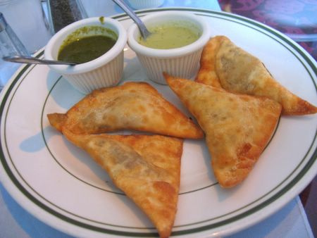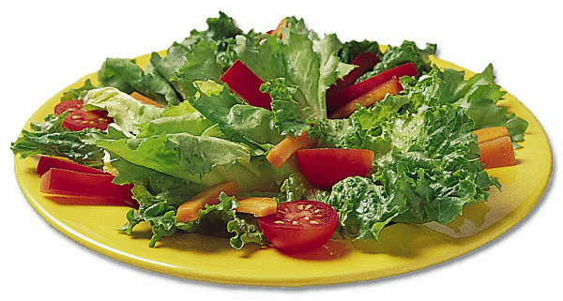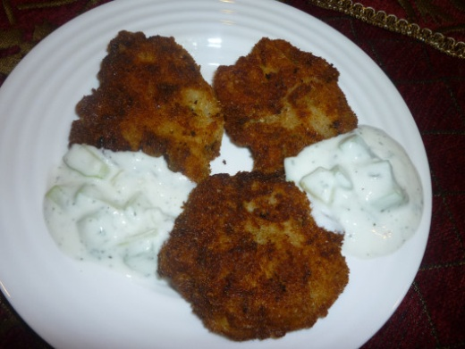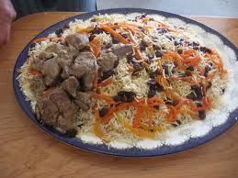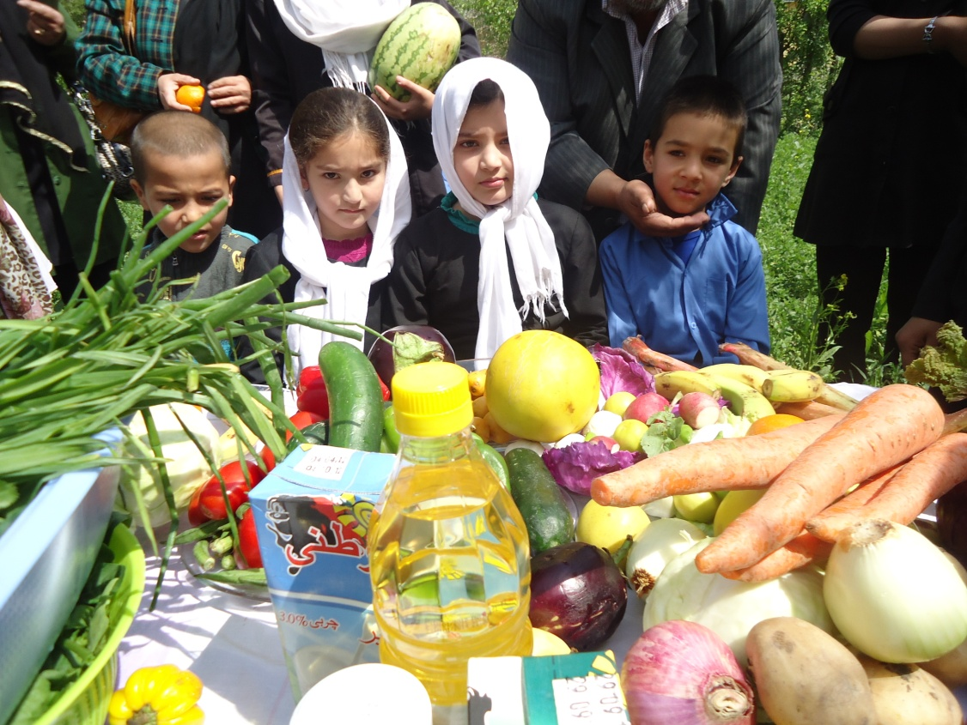

School age children need a variety nutritious and safe foods.
Wrong feeding of School Children
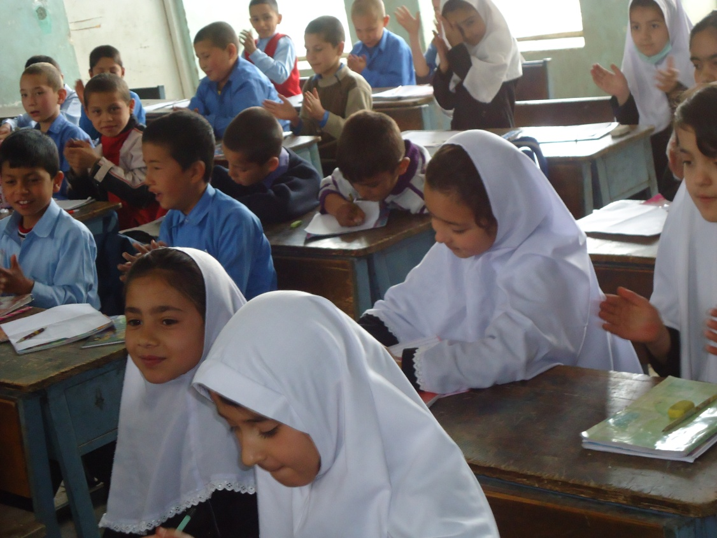
School age children and youth as with other members of a family need healthy, balanced diets. Especially girls need good nutrition, to bring healthy children in the future.
When boys and girls become adolescents, their need for nutritious food becomes higher. Because at that age the growth and development is very fast. That is why their dietary needs become greater and they eat more food.
School children that go to school hungry or haven’t had proper diet, usually have slower growth and development than the children at the same age. Often they may not have enough energy for playing, reading, learning, and other activities. Their academic performance may not be as good as children with good nutrition. They may not pay attention and may want to leave school early.
In most village and remote areas, children have to walk long distances to school. This increases their need to energy intake. Also in most villages children eat only a piece of bread without any other food as launch. Due to that, their food is not enough to learn and do other activities.

Children and youth need a healthy balance of food from all food groups
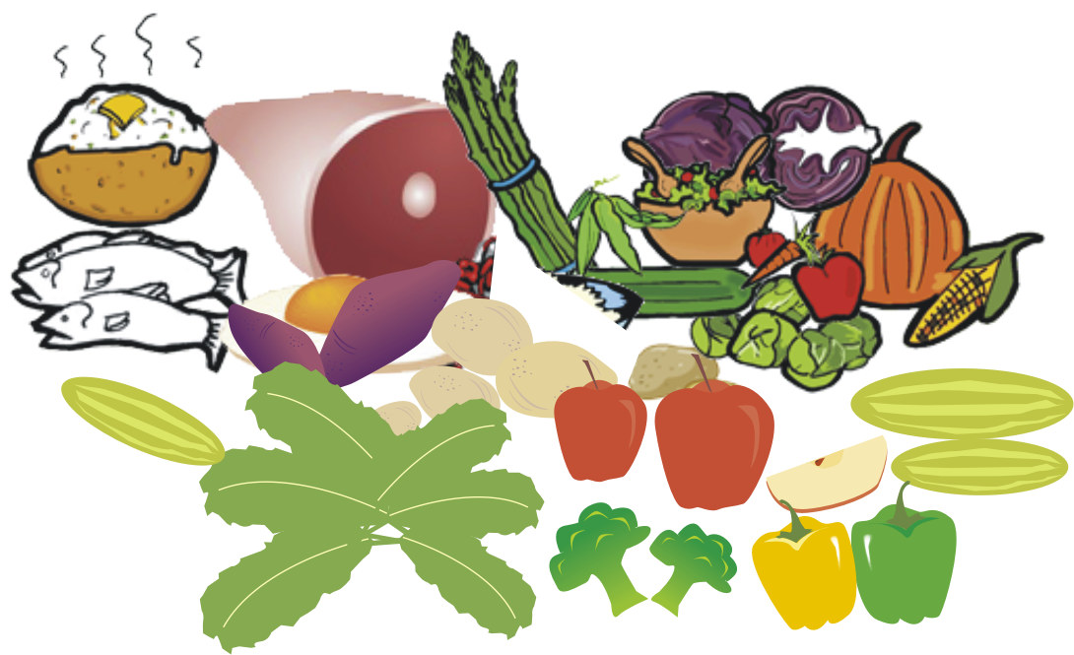

School Children Diet
School children’s diet must be healthy and full of energy
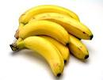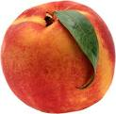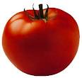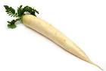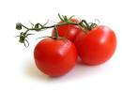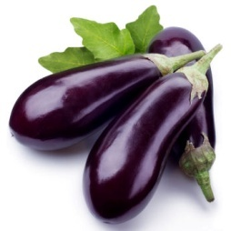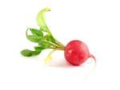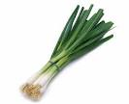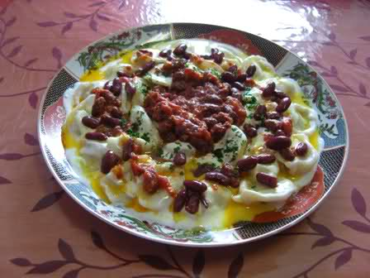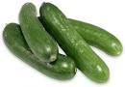

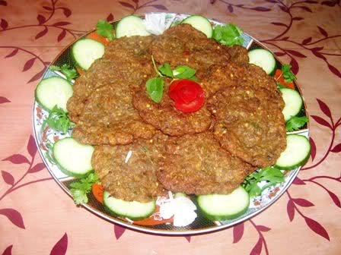

Healthy diets for school children should contain different foods. These foods should provide energy, and all the other necessary nutrients which a child needs for their growth and development. The greater the variety of the diet, the more likely it is to be adequate.
These healthy foods are:
- Starch(carbohydrate) foods and staples such as rice, wheat, corn, noodles and bread.
- Beans, peas, mung bean and if it is possible, some meat, fish and egg for protein.
- Vegetables such as green and orange vegetables (micronutrients and fiber).
- Milk and milk products such as cheese, kurut, cream and yoghurt (micronutrients, especially fat- soluble vitamins and calcium and fat).
- Adding some fat or oil to make food tasty and help absorb vitamins
- Fruits and if it is possible eating several kind of fruits in a day. Eating different fruits provide vitamins and help the absorption of minerals from vegetables. For example vitamin C in fruits will help absorption of iron from green vegetables.
Use of sugar and candies should be limited. Sweet foods make other foods tasty and provide energy. Eating of them is not necessary, but makes our diet delicious.
How Many Meals Do School Children Need?
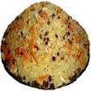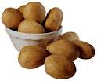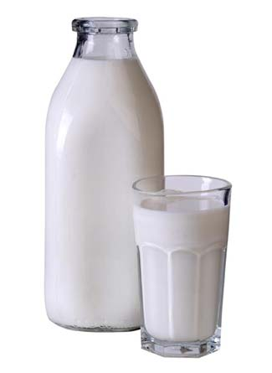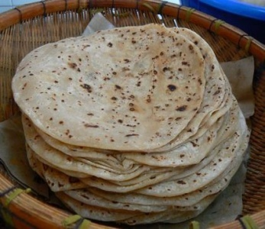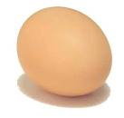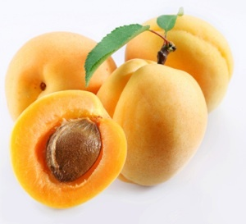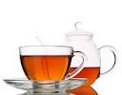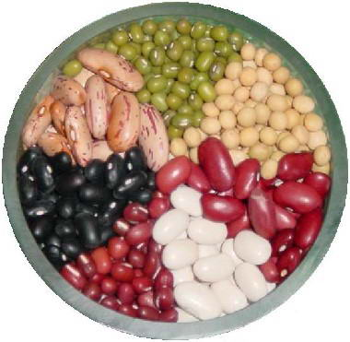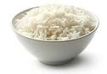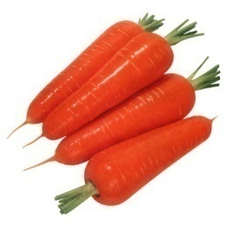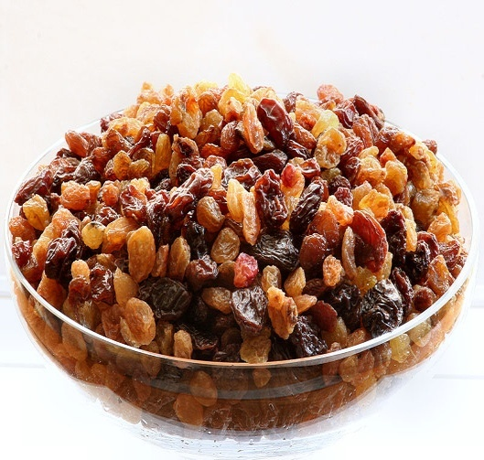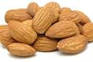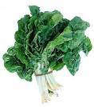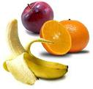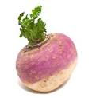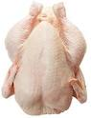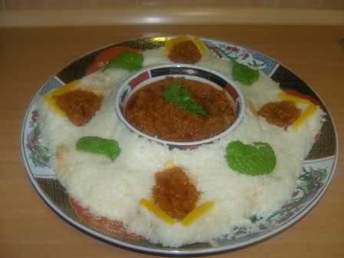

School age children need useful, healthy and nutritious foods. Because their growth and development rate is so fast, they need high-energy, varied and nutritious foods.
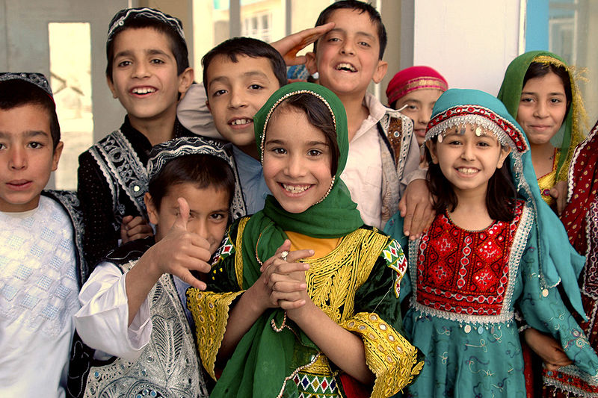
Beside snakes school age children need three meals a day:
The first meal breakfast: breakfast is a very important meal for school age children, especially when they have to walk long distances to school.
A good breakfast includes foods like, wheat, corn bread, halwa, Firni, boiled potato, boiled egg or fried in oil, milk, baked bean, peas and fruits.
One snake: help to provide energy for learning and playing. They can have a piece of wheat bread, corn bread, dry fruits or fresh fruits.
Lunch: it should include different foods. If schools not provide lunch, the parents have to prepare foods for their children to carry to school. Children, who go at noon to school, are encouraged to eat food before going to school. They should not go to school hungry.
Dinner: because children have fast growth and development, they need more foods than others. Due to that they often become hungry sooner than others, especially of playing sport at school, or walking long distances home. Children need to eat dinner during the evening. Dinner should provide different foods from all food groups.

REMEMBER MESSAGE
Hungry children cannot learn well.

EVALUATION
- Why do school age children need more foods?
- Why is eating breakfast or lunch so important before going school?
- If you go hungry to school, what will likely happen?

HOMEWORK (11)
- Speak about school age children feeding with your family members.
- Find a school age children in your family or neighborhoods, ask about his/her meal pattern.

Lesson10
Feeding adolescents
OBJECTIVES
You are going to learn and talk about:
- Food needs of school –age children.
- Hungry children find it harder to pay attention to lessons.
ASK YOURSELF
- Do I need food before coming to this lesson?
- Can I learn lessons- when I am hungry as well as when I am not?

STUDENTS ACTIVITY (12)
discuss following questions:
Why do we have to eat before coming to lesson?
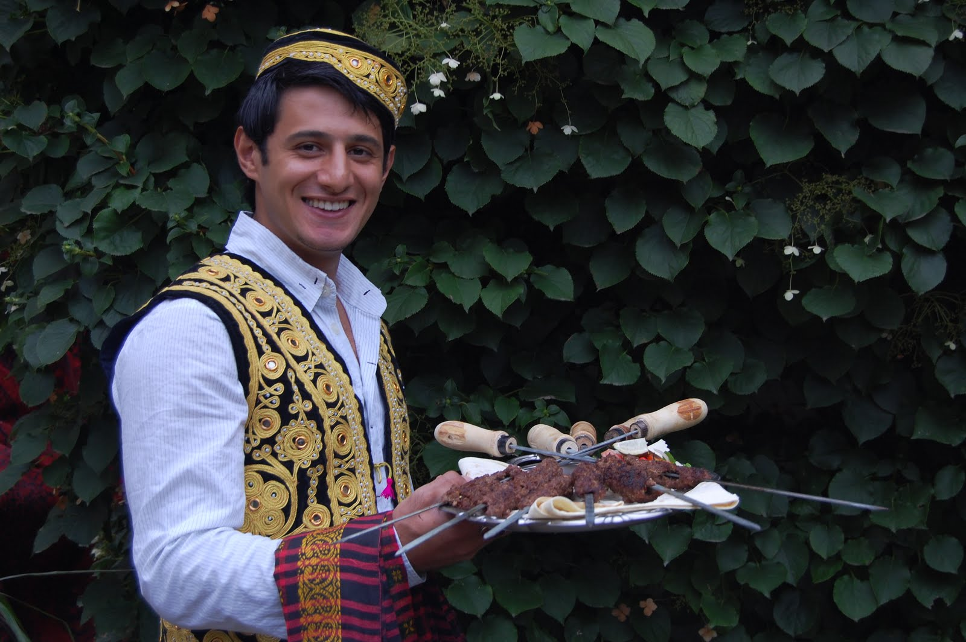
Discuss if you can learn lessons, while you are hungry?

READING

Adolescent also need three meals and some snacks each day. They should have:
- Breakfast- This is always important but especially so if she has to walk a long way to school or work and does not eat much at midday. One example of a good breakfast is a starchy food such as Shir-bring, bread with potato, or halwa with milk, or cooked beans, with cheese, butter and fruits;
- A meal in the middle of the day or lunch- parents should try to give adolescents a variety of different foods if they take food to school, FYEI class, college or work (e.g. bread, an egg, boiled potato and some fruit). If they buy food from street food vendors or shops, they should know which foods give the best value for money.
- A meal latter in the day or dinner- dinner also should be a good mixed meal and contain a variety of foods.
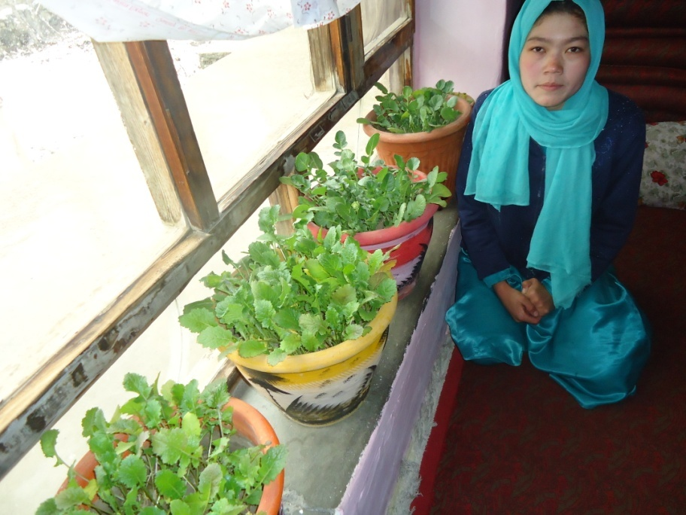
Micro gardens help me to have green leafy vegetables all the time.
Enjoy a wide variety of nutritious foods
Adolescents should be encouraged to:
- Eat plenty of vegetables, legumes and fruits
- Eat plenty of cereals (including breads, rice, pasta and noodles), and grains
- Include lean meat, fish, poultry and/or alternatives
- Include milks, yoghurts, cheese and/or alternatives. Reduced-fat milks are not suitable for young
- reduced-fat varieties should be encouraged for older children and adolescents
- Water, dogh, fresh fruit juices are good drinks for adolescents.
And care should be taken to:
- Limit saturated fat and moderate total fat intake.
- Choose foods low in salt
- Consume only moderate amounts of sugars and foods containing added sugars

Prevent excess weight gain
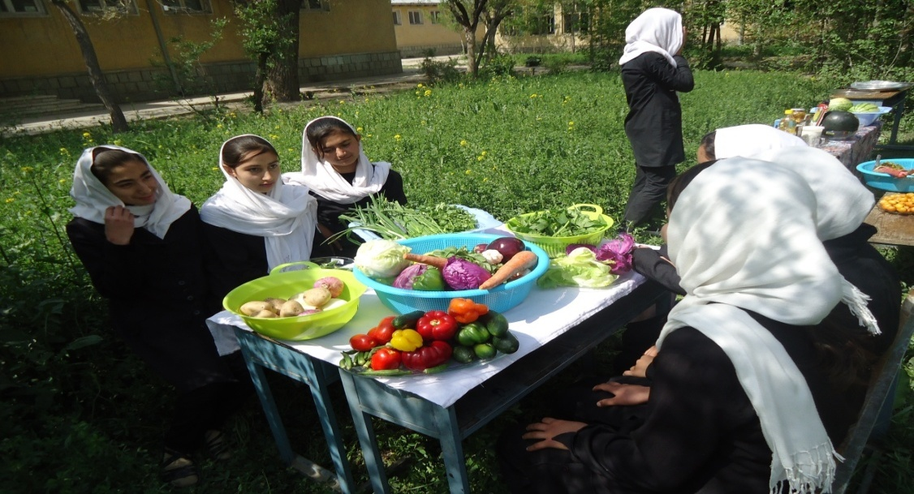
Enjoy a wide variety of nutritious foods!
Eat plenty of vegetables, legumes and fruits

Why are we getting fat?

Each day of our lives our bodies take on fuel through the food we eat. We constantly burn this fuel over the day as we move about. The more we move the more fuel we burn. If, at the end of a day, the body has fuel left over it is stored as fat – body weight increases a little. On the other hand, if we burn off more fuel than we have eaten, the body will use up some of its stored fat and– body weight will falls. Adolescents should aim to be neither underweight or overweight.
When body weight is stable the balance of food intake and physical activity is close to perfect and we will prevent excess weight gain. If weight is increasing the system is out of balance. This may be as a result of eating too much food, doing too little physical activity, or both.

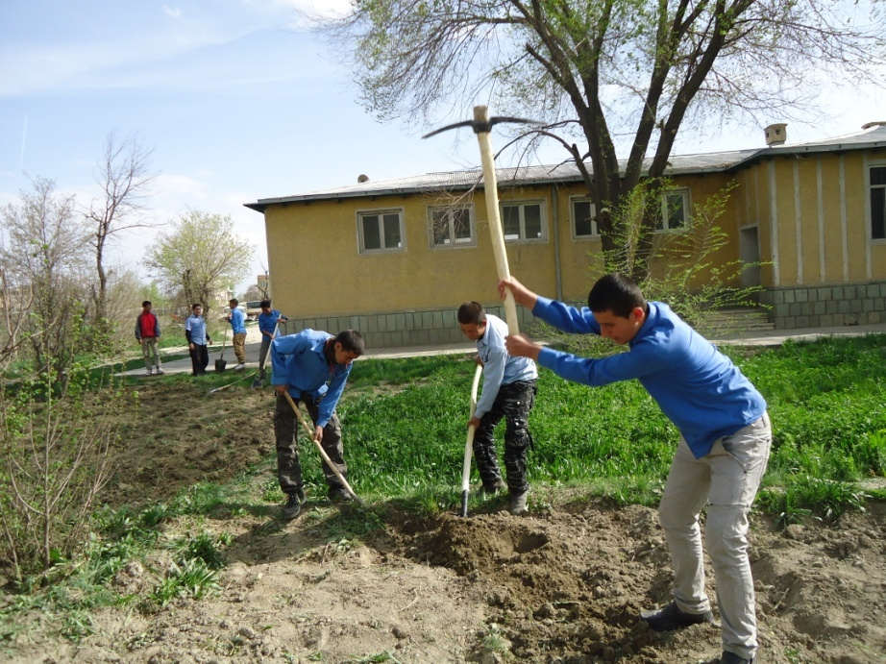
Be active every day

REMEMBER MESSAGE
Adolescents need sufficient nutritious foods to grow, be active and develop normally.

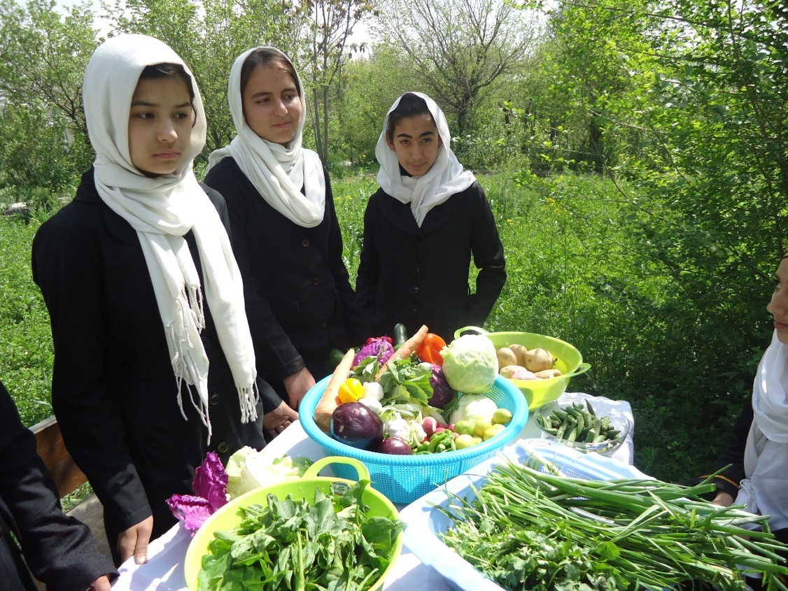

- It is particularly important that adolescent girls eat a good diet that supplies them with sufficient energy and nutrients.
- Parents must use iodized salt in family meals if it is available. Adolescents and young women who lack iodine cannot work or study well. Iodine- deficient girls who become pregnant risk having a baby who is mentally or physically damaged.
- Adolescents is a good time to break the cycle of undernutrition and can also ensure that young women who do get pregnant go in to the pregnancy with a good nutritional status. This is best both for the young mother and the baby.
- Adolescent youth should delay marriage as long as possible- at least until after 18 years of age.

EVALUATION
- Why do adolescents need more food?
- Why is eating breakfast or lunch important before going school or starting the day?
- If you go hungry to school or work, what will happen?

HOMEWORK (12)
- Speak about adolescent feeding with your family members.
- Think about your own adolescent feeding, when you were at highs school, and write 7 lines about your meal pattern. Next day present it to you classmates.

Chapter3
Special food needs
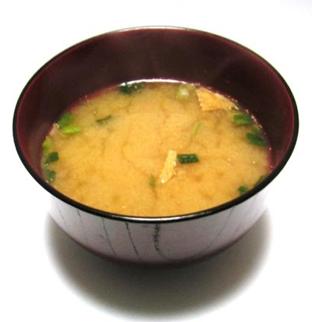
(Recipes for sick children)

Lesson1

Healthy foods for Improving health and nutrition of children with Diarrhoea

OBJECTIVES

You are going to learn and talk about:
- The importance of special foods for improving health and nutrition, especially during sickness.
- Improved foods for diarrhoeal patient.

ASK YOURSELF
- What foods will be good for diarrheal patients?
- Is eating vegetables good for diarrhea?
STUDENTS ACTIVITY (13)
Discuss the following questions:
In your point of view, what foods will be good for a patient with diarrhoea?
Whether these foods are good for diarrhoea? Why?
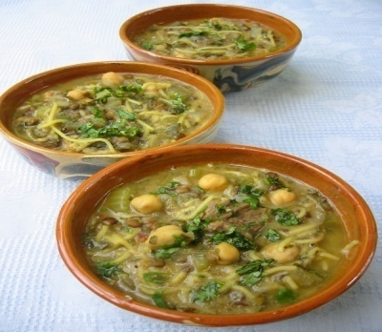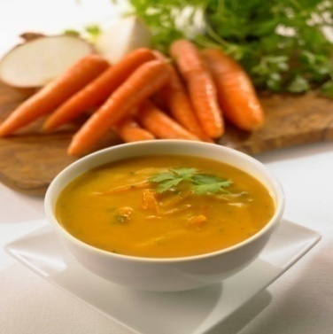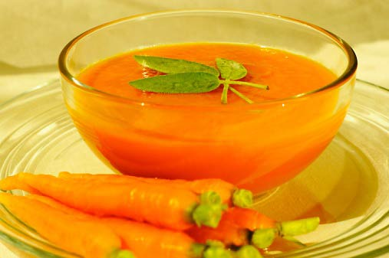

Noodles with vegetables and cereals, soup, soup-rice are improved foods for patient with diarrhoea. It is important to keep breastfeeding infants and young children when they have diarrhoea. For older children, they should be given ORT and zinc tablets and continue feeding. After the episode, they may need extra food for catch-up growth, as most children lose weight (or at least growth velocity) when having an infectious disease like diarrhoea.

READING

- Soft and mashed foods such as, wheat and rice halwa, that contain milk or mashed vegetables like pumpkin, carrot and potato are good for improving diarrhea. These foods provide nutrients and prevent malnutrition also.
- Eating foods such as white bread, potato, white rice and macaroni are also good for diarrhea. These foods will prevent weight loss.
- Drinking enough fluids, will help to maintain body fluids again. In diarrhea there is need to drink fluids such as shurba bring, shurba, soft fluids, fruits juice, dogh and milk.
When an infant is sick with diarrhoea, the mother has to continue breast milk. Mother’s milk helps infants to fight against sickness. Close contact of the mother give the child sense of security.
Mother milk is the only food necessary till six months of age. Breastmilk provides all the nutrients needed. Mother’s milk is always clean and safe, and prevents sickness and death of infants. Infants of 2 to 3 months of age are 4 times more likely to die of infectious disease if they are not breastfed Under 2 years they are almost 6 times more likely to die.

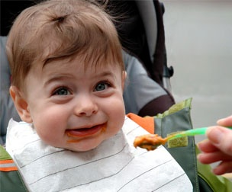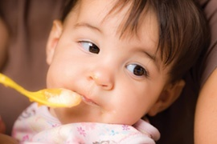
During illnesses, also the child should continue to be feed.

REMEMBER MESSAGE
A breast –feeding child should continue to be fed with breastmilk during the illnesses.

EVALUATION
- What foods should give for diarrheal patient?
- Are drinking fluids are useful for diarrhea?
- What treatment is recommended for diarrhea?
- Should the breast- feed child continue breastfeeding during illnesses? Why?
HOMEWORK (13)
Discuss about improved foods for diarrhea, with your family members.
Ask them, what other foods will be good for diarrhea? What treatment should they be getting?
Next day explain it to your classmates.

Lesson2

(White rice) Brinj Safed

OBJECTIVES
You are going to learn and talk about:

- The importance of white rice for diarrhea.
- White rice is an improved food for diarrhea.

ASK YOURSELF
- Is white rice a good food for patients?
- What foods can be made from rice?

STUDENTS ACTIVITY (14)
What foods can made from rice? Make a food from rice, and then explain how you made it.

INGREDENTS
One cup rice
2 cups water
small amount of iodized salt
2 cups yoghurt
one spoon mint
Cooking method
- At first wash the rice
- Add salt, and cook it in a pressure cooker for 10 minutes.
Add mint and yoghurt; give it to the person sick with diarrhoea.

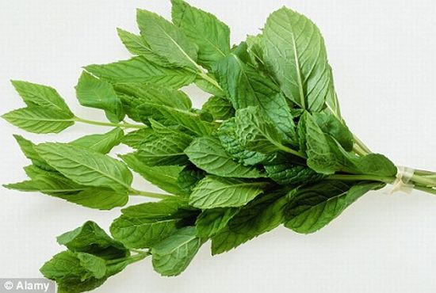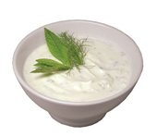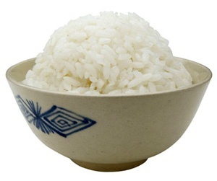
White rice with yoghurt is a good food for patient with diarrhoea.
REMEMBER MESSAGE
Feeding during illnesses, prevent malnutrition!

EVALUATION
- What other food items are used for cooking white rice?
- How do you prepare white rice?
HOMEWORK (14)
Explain the method of cooking white rice for your family.

Lesson3
Shorba Brinj (Rice- Soup)
OBJECTIVES
You are going to learn and talk about:

- The methods of cooking Shorba Brinj.
- Shorba Brinj is an improved food.

ASK YOURSELF
- Do I know how to cook Shorba Brinj?
- Is Shorba-Brinj an appetizing food?
STUDENTS ACTIVITY (15)
Speak about the following questions:
What are the other food items in Shorba-Brinj?
Are your family member, cook shurba bring?

Composition
2 table spoons rice
½ cup water
½ cup milk
2 table spoon diced carrot or pumpkin, spinach, coriander and garlic.
Iodized salt

Cooking method
- Add rice, milk and water in pressure cooker and cook it.
- Add diced or chopped carrot, pumpkin, spinach, coriander and garlic
- This food is good for anorexia, nausea and vomiting and cold.
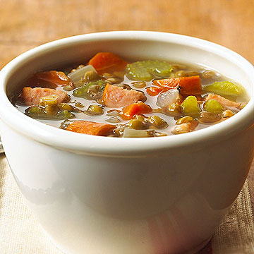
Shorba Brinj is an improved food for diarrhoeal patient.

REMEMBER MESSAGE
Use a variety of foods for continued feeding of sick children.

EVALUATION
- What food items are used to cook Shorba-Brinj?
- How is Shorba=Brinj cooked?
HOMEWORK (15)
Explain the method of cooking Shorba-Brinj to your family and why it can be considered a healthy preparation.
Lesson4
Food for Cold
OBJECTIVES

You are going to learn and talk about:

- The useful foods for a cold.
- Omach is a good food for cold.

ASK YOURSELF
- Am I ever affected by cold?
- What foods do we eat when we have a cold?

STUDENTS ACTIVITY (16)
Discuss the following question:
In your point of view, what foods are useful during a cold?
If you know any food, explain how it is cooked.

Food items need for cooking Omach
one cup wheat flour
10 cups water
iodized salt
2 turnips
2-3 carrots
2 tomatoes
100 g coriander, or vegetables found locally
one cup yoghurt

Cooking method
- Mix flour with ½ cup water, mush it to change in small grains;
- Boil ten cups of water and add vegetables;
- Add the dough grains to it and boil it again for 20 minutes;
- Eat it with yoghurt.
REMEMBER MESSAGE
Sick children should be fed repeatedly, with small amounts of food.

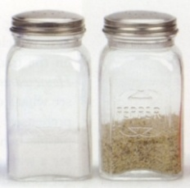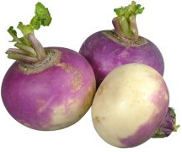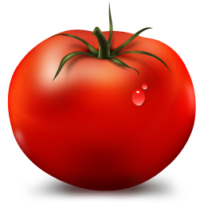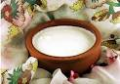
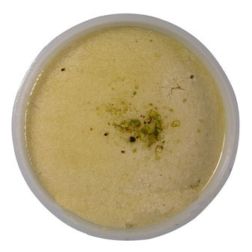

Omach is a useful food for
those sick with a cold.

EVALUATION
- What food items are used to cook Omach?
- Is Omach a good food for a cold?
- How can we cook Omach?

HOMEWORK(16)
Discuss with your family about the usefulness of Omach and the method of cooking with your family.

Chapter4
Improved Food Recipes
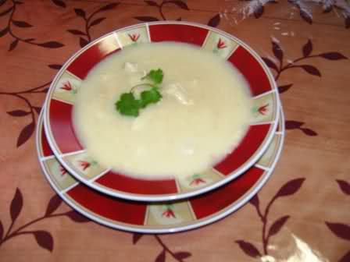

Lesson1
Shir- Brinj (Milky rice)
OBJECTIVES
You are going to learn and talk about:
- Sheer- Brinj is a healthy food.
- How Sheer- Brinj is cooked.

- ASK YOURSELF

- Have you eaten Shir- Brinj?
- What food items are used in Shir- Brinj?
- Is Shir- Bring a good food?

STUDENTS ACTIVITY (17)

Discuss the following questions:
Does your family cook Shir- Brinj?
Do you know how to cook Shir- Brinj?
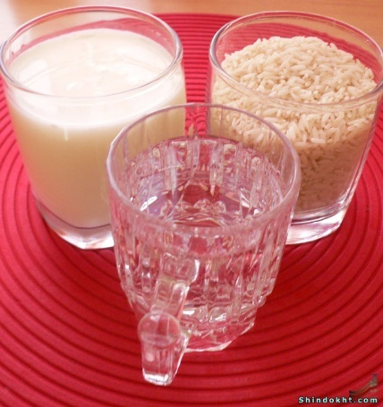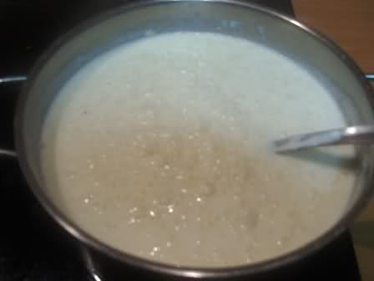
Composition
One cup rice
Four glasses water
Half cup sugar
One table –spoon oil
Cardamom
2 spoons mashed fruits like apple
2 cups mashed walnut or almond
small amount of iodized salt
Cooking method
- First boil the milk
- Wash rice and add it to the milk
- Then add the sugar and cardamom
- Cook it in lower temperature for 30 minutes
Put cooked Shire –Brinj in a plain plate and add chopped fruit and walnut.
REMEMBER MESSAGE
Good nutrition helps us to stay healthy and active longer.

EVALUATION
- What foods are used to cook Shir- Brinj?
- How do you cook Shir- Brinj?
- Is Shir- Brinj a good food? Why?

HOMEWORK (17)

Speak about cooking Shir- Brinj with your family member. Ask them, how they cook Shir- Brinj.

Lesson2
Potatoes with Bean

OBJECTIVES
You are going to learn and talk about:

- How to cook potato with bean.
- The nutritional importance of potato with bean.

ASK YOURSELF
- What foods are cooked with potato?
- Do potatoes cooked with bean provide us with energy?

STUDENTS ACTIVITY (18)
Discuss the following questions:
What other dishes are made with potato?
What other dishes are made with bean?

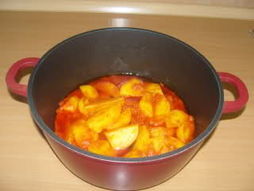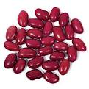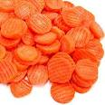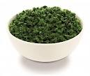

Composition
one potato, or half cup chopped potato
one table- spoon bean flour
one spoon oil
one cup water
one table- spoon chopped spinach or carrot
a little iodized salt.
Cooking method
- Peel potato, and cut it to small pieces.
- Mix bean flour with half cup of water and boil it.
- Then add the rest of the water and the diced potato to it. Cook it for 20 minutes.
- Add oil, vegetables and salt and boil for 2-3 minutes more.
REMEMBER MESSAGE
Potato with bean is a high energy food.

EVALUATION
- Do you like potato?
- Do you like bean?
- What other foods are cooked with potato and bean?
- Why we should use different food items in different foods?

HOMEWORK (18)
Speak about the method of cooking potato and bean with your family.

Ask them, what other foods are cooked with potato and bean. Next day explain it to your classmates.

Lesson3
Halwa from wheat and milk
OBJECTIVES
You are going to learn and talk about:

- Cooking Halwa with milk.
- The nutritional importanceof Halwa with milk.

ASK YOURSELF
- What foods are cooked with wheat?
- Is milk a good food? Why?

STUDENTS ACTIVITY (19)
Speak about the following questions:
What foods are made from milk?
What foods are made from wheat?

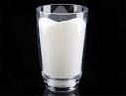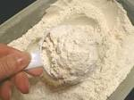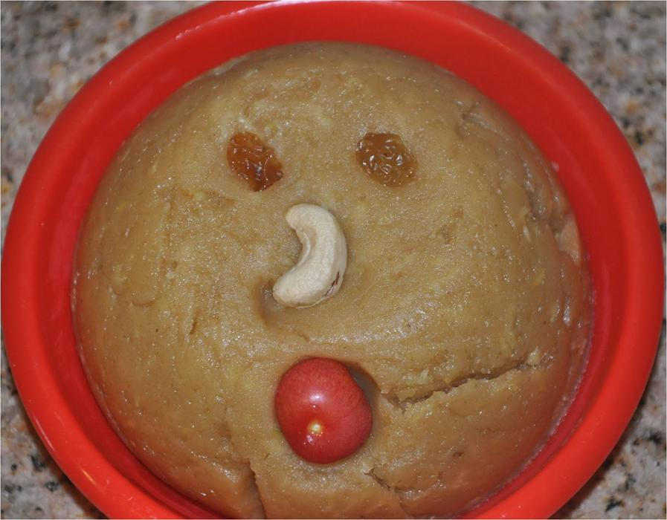
Halwa cooked with wheat and milk.

Food items
One table- spoon wheat flour
half cup milk
half cup water
one table- spoon oil
one table- spoon sugar
one table –spoon chopped carrot
a small amount of iodized salt
Cooking method
- Mix wheat flour with milk
- Add water to it, and boil for 10-15 minute. Then add oil, sugar and small amount of salt.
- Add chopped carrot and boil for 2-3 minutes.

REMEMBER MESSAGE
Wheat and milk has protein and many other nutrients, which make us healthy.

EVALUATION
- What food items are used to cook Halwa?
- How do you cook Halwa with milk?
HOMEWORK(19)
Speak about method of cooking Halwa with milk.
Discuss with your family members, what other foods can be cooked with wheat flour and milk. Note the foods and next day explain it to your classmates.

Lesson4
Firni

OBJECTIVES
You are going to learn and talk about:
-How to cook Firni.
- Nutritional importance of Firni.

ASK YOURSELF
- What flour can I use to cook Firni?
- What food items are used to cook Firni?

STUDENTS ACTIVITY (20)
Speak about the following questions:
From what flours can you cook Firni? What other food items are used to cook Firni.

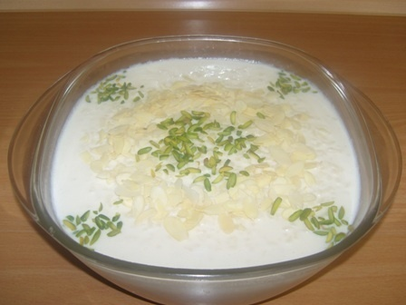
Firni is a high energy food.
Composition
One cup milk
One cup water
One table –spoon rice or soggy flour or corn flour (any kind of flour that is available).
One table –spoon bean flour
2 table-spoons of oil
2 spoons of sugar
an amount of cardamom
One spoon of mashed pistachio or almond(if available).
One spoon of chopped fruits like banana, or apple or raisins.
Cooking method
- Mix wheat and bean flour, oil and water to gather. Boil it for 5 minutes.
- Put it in a plain plate; add mashed fruits and pistachio to it.
REMEMBER MESSAGE
The flours that come from cereals and legumes are rich in nutrients and together produce high- quality protein.

EVALUATION
- From what flours can you cook Firni?
- How do you cook Firni?
- Is Firni a delicious food?
- Is Firni a nutritious food?
HOMEWORK(20)
Speak with your family about cooking Firni. Ask them how they cook Firni.

Lesson5
Pumpkin and egg mix (korma kadu)
OBJECTIVE
You are going to learn and talk about:
Cooking pumpkin with egg

ASK YOURSELF
- Have I eaten pumpkin with egg?
- What other food items are used in pumpkin mixed with eggs?

STUDENTS ACTIVITY (21)

Discuss the following questions:
Does your family cook pumpkin with egg mix?
Do you know how to cook pumpkin with egg?
Composition
A small pumpkin (1Kg)
2 table spoons oil
2 eggs
1 medium size onion
2 medium size tomatoes
1 glass of water
small amount of iodized salt
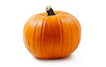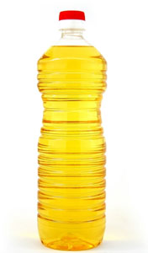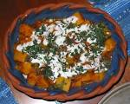
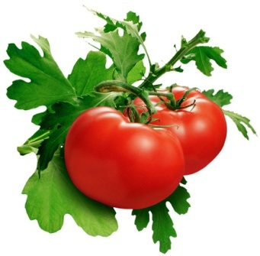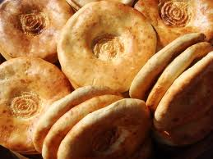
Cooking method
- Peel the onion, tomatoes and pumpkin and cut in to small pieces
- Put the oil in to the pot, add the onion and fry until the onion is light brown
- Add the tomatoes and then the pumpkin
- Add water and salt and cook for 5 minutes
- Beat the egg and add it to the cooked pumpkin
- Cook for 2-3 minutes until the egg is well cooked
Serve it with bread.
REMEMBER MESSAGE
Including different food items improve the nutritional value of recipes.

EVALUATION
- What foods are used to cook pumpkin with egg mix?
- How do you cook pumpkin?

HOMEWORK(21)

Speak about cooking pumpkin with egg with your family member.

Lesson6
Cabbage stew (Korma karam)

OBJECTIVES
You are going to learn and talk about:

How to cook cabbage korma.

ASK YOURSELF
- How can I cook cabbage?
- Do cabbage korma is a healthy food?

STUDENTS ACTIVITY (22)
Discuss the following question:
What other dishes are made with cabbage?

Composition
1 kg of small cabbage
2 cups of water
2 medium size onions (200gr)
2 medium size tomatoes
7 tablespoons oil
1 cup split peas (dalnakhot)
Iodized salt to taste.
1 cup yoghurt
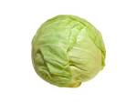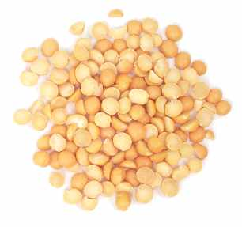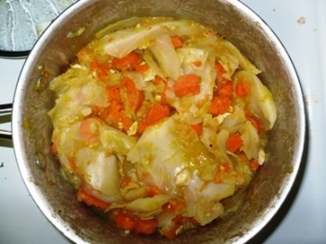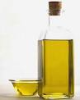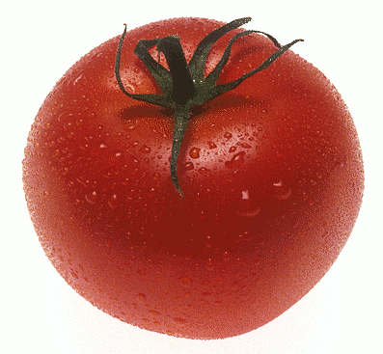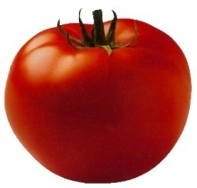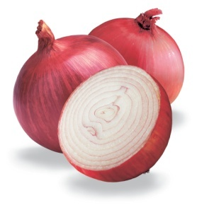
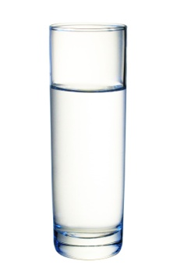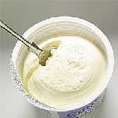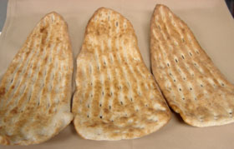

Cooking method
- Soak the peas for a few hours. Drain them, and cook in water for about 25 minutes in a normal pot or 10 minutes in a cooker pressure.
- Put oil in to a separate pot and add the onions
- Fry the onion until slightly brown
- Add tomatoes and cabbage and cook it for 10 minutes
- Add the cook peas and cook for 5 minutes more.
- Put yoghurt and serve it with bread.
REMEMBER MESSAGE
Cabbage korma with peas provide nutrients to your body.

EVALUATION
- Do you like cabbage?
- Do you like peas?
- What other foods are cooked with peas and cabbage?

HOMEWORK (22)
Speak about the method of cooking cabbage and peas with your family.

Lesson7
Egg plant stew (Badanjan korma)
OBJECTIVES
You are going to learn and talk about:

How to cooking eggplant korma.

ASK YOURSELF
- What other dishes are cooked with eggplant?
- Is eggplant with milk products a healthy recipe? Why?

STUDENTS ACTIVITY (23)
Speak about the following questions:
What other recipes are cooked with eggplant korma?
Write the name of those recipes and explain to your classmates.

Food items
5 medium eggplants (1kg)
4 medium potatoes (1/2)
2 large tomatoes (250gr)
10 tablespoons oil (200gr)
4 cloves of garlic (50gr) 2 for dish, 2 for kurut
2 medium size onions (200gr)
2 cups kurut, Chaka or yoghurt (1/2kg)
Iodized salt to taste
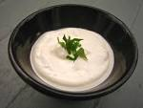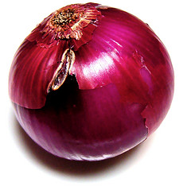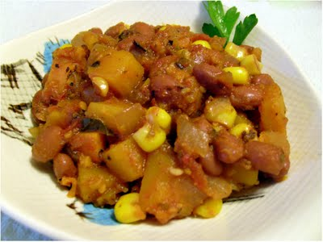
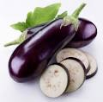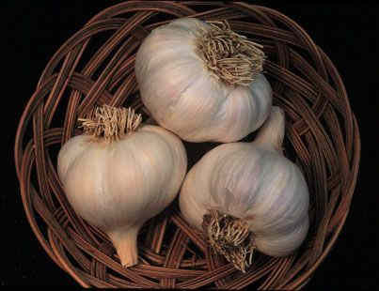

Cooking method
- Fry the onion until light brown
- Add chopped tomatoes and garlic
- Add potatoes and garlic
- Add tomatoes, eggplants and ½ glass of water and cook for 20 minutes
- Take off from the heat and add the kurut, Chaka or yoghurt and serve with bread.

REMEMBER MESSAGE
Vegetable recipes are healthy recipes.

EVALUATION
- What food items are used to cook Eggplant korma?
- How do you cook eggplant korma?
HOMEWORK (23)
Speak about method of cooking eggplant with your family.
Discuss with your family members, what other foods can be cooked with eggplant and milk products. Note the dishes and next day explain it to your classmates.

Lesson8
Okra stew (korma Bamia)

OBJECTIVES
You are going to learn and talk about:
How to cook okra stew.

ASK YOURSELF
- What food items I use to cook okra stew?
- Is my family cook okra? How they cook it?

STUDENTS ACTIVITY (24)

Cook a recipe with okra. Note the ingredients and cooking method, and then present it to your classmates.
Composition
1 ½ kg of okra
2 medium size onions
4 medium size tomatoes
4 cloves of garlic
5 green pepper (optional)
1 cup of water
5 tablespoons of oil
Iodized salt to taste
2 cups yoghurt
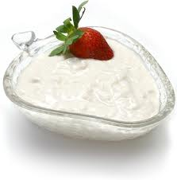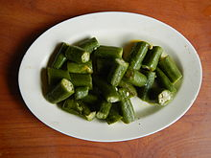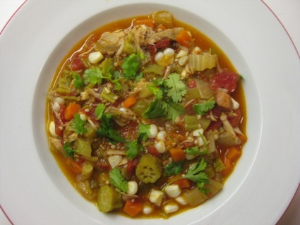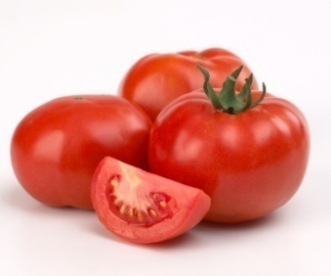
Cooking method
- Wash the okra, tomatoes and pepper with water
- Peel the onions and cut them finely in to small pieces
- Add oil and onion in a pot and heat until the onion color changes to light brown
- Add the cut tomatoes, okra, pepper and garlic and leave it for 20 minutes (if use a pressure cooker, leave for 10 minutes).
- Serve it with bread.

REMEMBER MESSAGE
Vegetable recipes help our body to get different micronutrients.

EVALUATION
- How do you cook okra?
- Is okra a nutritious recipes?
HOMEWORK (24)
Speak with your family about cooking okra. Ask them how they cook okra.

Revision
The human life cycle begins at fertilization, when an egg cell inside a woman and a sperm cell from a man fuse to form a one-celled zygote . Over the next few days, the single, large cell divides many times to form a hollow ball of smaller cells.
Birth takes place between fertilization and 40 weeks following fertilization, at which point the baby is fully formed and ready to exit the mother's uterus and enter the world. During the birth stage, the baby begins as a single cell, which proceeds to multiply into many cells that form the body parts and organs of new human life.
Infancy is the second stage. From birth through the first year of life, a person is called an infant. The infant is totally dependent upon his or her parents for food, changing, bathing and movement from place to place. This is a stage in which a person begins to learn lots of things about survival in the world. Infants’ bodies grow and develop rapidly, though not as fast as the brain.
Childhood is the third stage, which lasts for about ten years. For the first two years after infancy, the child is called a toddler. Toddlers learn how to walk, talk and become more independent. For the balance of childhood, people grow, gaining more freedom and responsibility as they learn about themselves.
Adolescence is the fourth stage, roughly from age 12 to 18 years. In this stage, starting with puberty, boys change and become men, and girls become women. This can be a very confusing time for a young person, trying to cope with so many changes. This is the time that the human is preparing for adulthood, growing to his/her maximum size, and is physically able to reproduce.
Adulthood is the fifth stage, from the end of adolescence, usually age 18 to 20, to old age. Adulthood is the time that people take on many different kinds of responsibilities. All of the things that our parents once provided, we must now provide for ourselves. The life cycle usually starts over again during this stage, when, through reproduction, adults give birth to their own children.
Girls and women need to eat well throughout their lives but particularly when they are planning a baby, are pregnant or breast –feeding. If they eat healthy, balanced diets they are likely to:

Stay active and well;
Produce healthy babies and breastfeed successfully.

A woman is at risk of complications and a difficult labour if she is already under nourished when she becomes pregnant, or is undernourished during pregnancy and so does not gain enough weight during the pregnancy leading her newborn baby more likely to have a low birth weight (< 2500 g).
Women of child-bearing age have certain nutritional needs above those of adult males. One reason is that the loss of blood during menstruation leads to a regular loss of iron and other nutrients and makes women more prone than men to anaemia. In addition, however, in our country women work much harder. In rural areas they are often heavily involved in agriculture, and in urban areas they may work long hours in governmental offices, factories and elsewhere; yet when they return home from the field or the factory or office they still have much work to do in the household, including food preparation and child care.
All girls and women of reproductive age should:
Eat a healthy, balanced diet that contains plenty of iron- rich foods;
Have plenty of clean, safe drinks;
Eat iodized salt. Women who lack iodine when they become pregnant are at greater risk of having a baby who is physically and mentally damaged.
During pregnancy a woman’s nutritional needs become greater shall at other times in her life. Her diet needs to provide all the elements needed for the growth of a fertilized ovum or egg into a viable fetus and baby. As the woman nourishes herself she also nourishes the growing fetus as well as the placenta to which the fetus in her uterus is attached by its umbilical cord. At the same time her breast tissue prepares for lactation.
The nutritional stores of a lactating woman may already be more or less depleted as a result of the pregnancy and the loss of blood during childbirth. Lactation raises nutrient needs, mainly because of the loss of nutrients first through colostrum and then through breastmilk.
Breastmilk volume varies widely, but for fully breastfed babies around four months of age, it is often 700 to 800 ml per day. It may rise later to as much as 1 000 ml or more. The nutrients present in this milk come from the diet of the mother or from her nutrient reserves. It is recommended that mothers exclusively breastfeed their infants for six months and then begin to introduce other food while continuing to breastfeed for as long as they wish, often into the second year or beyond.

An infant is a young child less than 1 years of age (from birth until first birth day). An infant is most likely to be healthy, if the full-term birth weight is at least 2.5 kg.

A baby will triple his or her birth weight by the first birthday. By the time she reaches six months. Her weight gain will start to slow down and weight gain will become more irregular due to growth spurts. The desired weight gain depends on the baby’s size, gestational age, and health. It might be as little as 5 grams a day for a tiny premature baby at 24 weeks, or 20 grams a day for a larger baby at 33 weeks and more for a full- term baby. In any case, a baby should gain about 15 g each day for every pound he or she weighs).
exclusive breast feeding means an infant receiving only breast milk from the mother, or expressed breast milk, and no other liquids or solids except drops or syrups consisting of vitamins, minerals supplements or medicines if needed e.g. when the baby was premature.
The mother should breast –feed exclusively until the baby is six months (180 days) old.
At six months of age complementary feeding should be introduced gradually while the infant continues to be breastfed intensively and to receive most of his or her energy and other nutrients from breastmilk and not from complementary foods. From six to 12 months, it is highly desirable that breastfeeding should continue and that the child should get as much milk as possible from the mother while other foods, first semi-solid and then solid, should be introduced to the diet of the infant for normal growth and health.
Breastmilk is relatively deficient in iron, and the infant’s store of iron is sufficient only until about six months of age. From six to 12 months, the normal infant may be expected to gain between 2 and 3 kg. The infant, while continuing to receive breastmilk, will now need foods to provide extra energy, protein, iron, vitamin C and other nutrients for growth.
Children from 2- 6 years of age need enough food to grow and develop and their stature to become tall.
Enough food provides them energy to play, run, walk, and fight infections. Starting good feeding habits in the first stages of life help children to have good nutrition habits in to adulthood. Because this period is very essential in their life, children learn most important habits during this time. When a young child learns to eat nutritious diet, he is more likely to do the same in adolescence and adulthood.
School age children and youth as with other members of a family need healthy, balanced diets. Especially girls need good nutrition, to bring healthy children in the future.
When boys and girls become adolescents, their need for nutritious food becomes higher. Because at that age the growth and development is very fast. That is why their dietary needs become greater and they eat more food.
Noodles with vegetables and cereals, soup, soup-rice are improved foods for patient with diarrhoea. It is important to keep breastfeeding infants and young children when they have diarrhoea. For children older than 6 months, they should be given ORT and zinc tablets and continues feeding. After the episode, they may need extra food for catch-up growth, as most children lose weight (or at least growth velocity) when having an infectious disease like diarrhoea.

The improved family feeding recipes are good for pregnant and lactating women. Pregnant and lactating women get a little extra than usual when serving these foods. This is essential if they are to meet their own food needs and those of the growing baby.

References
FAO/UNICEF/.2008. Healthy food, happy baby, lively family. FAO
Improved feeding practices and recipes for Afghan children and mothers FAO-2008

FAO. Burgess, Ann, and Glasuer, Peter, Family nutrition guide. FAO food and nutrition division.
MoPH.2010.National guidelines on micronutrients. (prevention, control and treatment). From Ministry of Public Health Afghanistan.

Ethiopia Public Health Training Initiative. February 2004. Trainer’s Guide. Using the Essential Nutrition Actions to Improve the Nutrition of Women and Children in Ethiopia, including under Situations of Emergencies and HIV and AIDS

FAO 2005. Volum1 and 2. Nutrition Education in Primary Schools. A planning Guide for curriculum development. 2005.

2004. Curriculum Development Centre, Zambia and, the Food and Agriculture Organization of the United Nations. Nutrition Education Pupil’s Book Grade 2, Grade 4 and Teacher Guides. FAO, Zambia. 2004.
Health Messenger. AMI. Salamati Magazine. The health magazine for Afghan health workers published by Aide Medical International. Serial No, 31. 2004

Health Messenger. AMI. Salamati Magazine. The health magazine for Afghan health workers published by Aide Medical International. Serial No, 37. 2008

The Community Guide - Promoting Good Nutrition
www.thecommunityguide.org/nutrition/index.html‏

U.S. Department of Agriculture
www.usda.gov/

Nutrition for Everyone: Basics: Food Groups | DNPAO | CDCwww.cdc.gov/nutrition/everyone/basics/foodgroups.html

‏Food Groups - ChooseMyPlate.gov - USDA

www.choosemyplate.gov/food-groups/

‏What Are The Main Food Groups & Their Function ... - Livestrong.com

www.livestrong.com/article/40947-main-groups-function/

‏A List of the Major Nutrients Provided by Each Food Group | Healthy ...

healthyeating.sfgate.com/list-major-nutrients-provided-food-group-1659.html

‏Nutrition for Everyone: Fruits and Vegetables | DNPAO | CDC

www.cdc.gov/nutrition/everyone/fruitsvegetables/

Fruits & Veggies More Matters : Home : Health Benefits of Fruits ...
www.fruitsandveggiesmorematters.org/‏

Color Wheel of Fruits and Vegetables - Disabled World
www.disabled-world.com/artman/publish/fruits-vegetables.shtml

Fruit and vegetable - types | Better Health Channel
www.betterhealth.vic.gov.au/bhcv2/.../fruit_and_vegetable_types?...

Fruits and vegetables news, articles and information: - Natural News

www.naturalnews.com/fruits_and_vegetables.html

‏Tips for Fruits and Vegetables - Canada's Food Guide
www.hc-sc.gc.ca/fn-an/food-guide.../fruit/tips-trucs-eng.php

‏Fresh Fruit & Vegetable Program - Food and Nutrition Service

www.fns.usda.gov/cnd/ffvp/

‏Fruits and Vegetables - American Heart Association
www.heart.org/.../Fruits-and-Vegetables_UCM_302057_Article.jsp

‏Color Wheel of Fruits and Vegetables - Disabled World

www.disabled-world.com/artman/publish/fruits-vegetables.shtml

Do Colors in Fruits & Vegetables Play an Important Role? | Healthy ...
healthyeating.sfgate.com/colors-fruits-vegetables-play-important-role-1660.html

‏What Color is Your Food? Taste a rainbow of fruits and vegetables ...
www.ag.ndsu.edu/pubs/yf/foods/fn595.pdf

‏Fruits and Vegetables Rainbow - Sesame Street
www.sesamestreet.org/cms_services/services?action=download&uid...

‏What Is Nutrition? Why Is Nutrition Important? - Medical News Today

www.medicalnewstoday.com/articles/160774.php

‏Nutrition Journal

www.nutritionj.com/

WHO | Nutrition
www.who.int/nutrition

Requirements at Different Life Stages | CARTA
carta.anthropogeny.org/moca/.../requirements-different-life-stages

Food and your life stages | Better Health Channel

www.betterhealth.vic.gov.au/bhcv2/.../food_and_your_life_stages?...

GCSE The Dietary Needs Of Individuals At Different Life Stages ...

www.markedbyteachers.com/.../the-dietary-needs-of-individuals-at-different-life-stages.html‏

Different Dietary Needs at Different Life Stages - Marked by Teachers

www.markedbyteachers.com/.../different-dietary-needs-at-different-life-stages.html

Life Stages and Nutrition - Nutritionist Resource
www.nutritionist-resource.org.uk/articles/life-stages.html

Health and Nutrition Needs througout Life's Stages; Resources and ...

liferaydemo.unl.edu/web/fnh/lifestages

Nutritional Needs Vary With Life Stage, Lifestyle ... - Medscape
www.medscape.com/viewarticle/583041_4‏

Extremely Unhealthy Eating Habits to Avoid / Nutrition / Healthy ...

www.fitday.com/...eating/5-extremely-unhealthy-eating-habits-to-avoid.html

Unhealthy Food Habits - Healthy Diet Habits

www.healthy-diet-habits.com/unhealthy-food-habits.html

Avoid Unhealthy Eating Habits - WebMD
www.webmd.com/diet/features/avoid-unhealthy-eating-habits

5 Most Common Bad Eating Habits | 3FC
www.3fatchicks.com/5-most-common-bad-eating-habits/‏

WHO | Antenatal care - World Health Organization
www.who.int/rhl/pregnancy_childbirth/antenatal_care

Antenatal care: Definition antenatal care - Doctissimo

pregnancy.doctissimo.com/pregnancy-a-z/antenatal-care.html‏

antenatal - definition of antenatal by the Free Online Dictionary ...

www.thefreedictionary.com/antenatal

Antenatal Care Tips | Antenatal Care during Pregnancy
www.onlymyhealth.com/antenatal-care-tips-1298540334

Your Pregnancy Diet Guide | CompletePregnancyDiet.com
www.completepregnancydiet.com/

Pregnancy Week by Week, Pregnancy Information | Pregnancy.com

www.pregnancy.com/‏

Pregnancy Week by Week Calendar Pregnancy Symptoms and ...

pregnancy.about.com/‏

Pregnancy Center - WebMD
www.webmd.com/baby/default.htm

American Pregnancy Association - Promoting Pregnancy Wellness
americanpregnancy.org/

Pregnancy Week by Week: Body Changes Baby Development ...

www.medicinenet.com/pregnancy/article.htm

WHO | Postnatal care

www.who.int/maternal_child_adolescent/.../postnatal_care/en

Postnatal Care (Puerperium) | Doctor | Patient.co.uk
www.patient.co.uk/.../Postnatal-Care-(Puerperium).htm‏

Postnatal care - World Health Organization

www.who.int/pmnch/media/publications/aonsectionIII_4.pdf

Healthy post-natal care
www.medicine.ox.ac.uk/bandolier/booth/hliving/healpona.html

Natural family planning - Wikipedia, the free encyclopedia

https://en.wikipedia.org/wiki/Natural_family_planning‏

Welcome to Family Planning

www.familyplanning.org.nz/‏

CDC - Tools for Community Action - Healthy Communities Program

www.cdc.gov/healthycommunitiesprogram/tools/

Household food security & community nutrition - FAO

www.fao.org/food/household-food...community-nutrition/en/

Growing the Next Generation: Strategies to Improve Nutrition

home.preventioninstitute.org/growing.html

Essential Nutrition Actions Improving Maternal-Newborn-Infant and ...

www.who.int/nutrition/EB128_18_backgroundpaper2_A_

Programming Guide on Infant and Young Child Feeding - Unicef
www.unicef.org/nutrition/.../Final_IYCF_programming_guide_June_2012.pdf

National Nutrition Action Plan 2012-2017 - Scaling Up Nutrition

scalingupnutrition.org/wp.../Kenya_KNN_Action-Plan_2012_2017.pdf‏

Human nutrition in the developing world - FAO
www.fao.org/docrep/W0073e/w0073e03.htm‏

What Is Malnutrition? What Causes Malnutrition?

www.medicalnewstoday.com/articles/179316.php‏

What is malnutrition? | WFP | United Nations World Food ...

www.wfp.org/hunger/malnutrition

Malnutrition - National Library of Medicine - PubMed Health
www.ncbi.nlm.nih.gov/pubmedhealth/PMH0001441/‏

Malnutrition: MedlinePlus Medical Encyclopedia

www.nlm.nih.gov/medlineplus/ency/article/000404.htm

WHO | Water-related diseases - World Health Organization
www.who.int/water_sanitation_health/diseases/malnutrition/‏

Ethiopia. ENA Counselor’s guide. 2008. Key behaviours for optimal breastfeeding, complementary feeding and maternal nutrition at critical stages in the life cycle of women and children. Ethiopia. ENA, 2008.

USAID.AED. Ethiopia. March 2005.TRAINING OF TRAINERS MODULE WOMEN’S NUTRITION THROUGHOUT THE LIFE CYCLE AND IN THE CONTEXT OF HIV AND AIDS.
2005

Australian Department of health and Agriculture. Dietary guidelines for Australians. A guide to healthy eating. May. 2005

WHO. 2012. Office for the Eastern Mediterranean. Promoting a healthy diet for the WHO Eastern Mediterranean Region: user-friendly guide

World Health Organization. UNICEF. 2003.Geneva. Global Strategy for Infant and Young Child Feeding.

World Health Organization. UNICEF. 2007.Planning Guide for national implementation of the Global Strategy for Infant and Young Child Feeding.

World Health Organization. 2003. Geneva. Infant and Young Child Feeding. A tool for assessing national practices, policies and programmes.

Fact sheets: Better health channel

www.betterhealth.vic.gov.au

WFP.UNICEF. The essential package. Twelve interventions to improve the health and nutrition of school-age children.

Australia. 1999.National health and medical research council. Dietary guidelines for children and adolescents

FAO. Brian Thompson. Leslie Amoroso. Combating Micronutrient Deficiencies: Food-based Approaches.

FAO.Rome.2005. Promoting lifelong healthy eating habits. Setting up and running a school garden. A manual for teachers, families and communities. 2005

An Australian Government, State and Territory health imitative. Printed July 2007.Healthy Nutrition Curriculum Kit for South Australian Primary Schools.

Department of Education and Training, ‘Smart eating package for schools

www.sofweb.vic.edu.au/scln/smarteating.htm

Child and Youth Health, South Australia www.cyh.com
Food Safety Unit, Department of Human Services, Victoria www.foodsafety.vic.gov.au
Dietary Guidelines for Children & Adolescents; search the National Health & Medical Research

Council site www.nhmrc.gov.au
US Child Health site www.keepkidshealthy.com
Center for Science in the Public Interest; child nutrition site www.smart-mouth.org
What’s There to Eat? www.health.vic.gov.au/nutrition/child_nutrition/eat.htm#tipsheetsPARENTS

